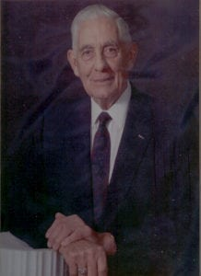 | 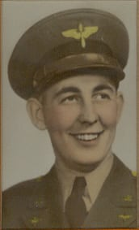
S. Gus Alexander
Mr. S. Gus Alexander began his illustrious career at North Texas Agricultural College (NTAC) in 1938-1939. A native Texan, he had graduated from North Dallas High School and later attended Southern Methodist University. While at NTAC, where he was a member of the Sam Houston Rifles, he met his future wife, Louise Harris of Cleburne. His interest in NTAC later resulted in his establishment of a 4-year scholarship fund named in his honor.
Mr. Alexander volunteered in 1940 for service in the U. S. Army Air Corps and was inducted in 1941. He graduated from cadet aviation training at Randolph Field and received his wings and commission at Kelly Air Base in San Antonio, Texas. He served as a pilot with the 8th Air Force in Europe. During his tour of duty he flew 40 missions, served as Lead Pilot, Operations Officer, Command Pilot, and Squadron Commander. He was one of the first Pathfinder pilots to fly both the B-17 and B-24. He participated in such missions as Ludwigshafen, Mannheim, Cologne, Essen, Berlin, Normandy, and low level attack missions in connection with the U. S. Army crossing of the Rhine. He served in the 814th Bomb Squadron, First Air Division and in the 706th Bomb Squadron, 446th Bomb Group 2nd Air Division. He returned to the U. S. at the end of the war in Europe, and served as a Squadron Commander and Instrument Instructor and Check Pilot. He left the service in 1946 and moved to Duncanville, Texas.
In 1956, he organized Flame Inc., a building development, and rental corporation, which later grew into a large thriving business. He serves as President and General Manager. He organized the Duncanville Home Builders Association and served as their first President. He was awarded the Hugh Prather award as outstanding Home Builder in Dallas County (the highest award that is presented by the Homebuilders association in the Metropolitan Dallas area).
He served on the Duncanville School Board for six years. He organized the Duncanville Foreign Language and Travel Program. The program was the first of its type to be approved by the State Board of Education. He assisted in organizing the first Cub and Boy Scout troops and the first Little League Baseball Association in Duncanville. Mr. Alexander served as Chairman of the Board of Trustees for the Dallas South District of the United Methodist Church, Board of Directors of Methodist Hospitals, Chairman of the Duncanville Hospital Authority, President of the Duncanville Chamber of Commerce, Board of Directors of American Bank, and President of the Evening Lions Club. He served on several occasions as Chairman of the United Way and Cancer Fund drives. He assisted in organizing the SIL Anthropology Museum and served on its Board of Directors. He served on the committee responsible for the War Memorial dedicated to Duncanville’s war dead.
His military awards include the Distinguished Flying Cross with two Oak Leaf Clusters, Air Medal with four Oak Leaf Clusters, Bronze Star, and Presidential Unit Citation. He was the recipient of many civilian honors. He received the Jaycee Outstanding Citizen Award in 1973.

