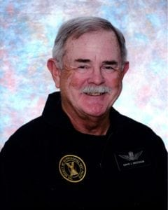 | 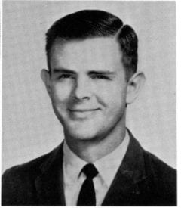
LTC (Ret) David J. Anderson
David J. Anderson was born in Corsicana, Texas, and raised in Dallas. He is a graduate of Bryan Adams High School (1961), and was an ROTC cadet for three years. He entered Arlington State College, majoring in aerospace engineering in the spring of 1962, and was an ROTC cadet, rising to the position of Deputy Corp Commander in 1968. He became an Engineering co-op Student with Bell Helicopter in 1964, in the Aerodynamics Group. Halfway through his ROTC course he was selected for the ROTC Flight Program, where he earned his first pilot’s license. Upon completing his ROTC studies he was designated as a distinguished military graduate. Because of financial and family health reasons he was forced to leave college, but was admitted into the Army as a Second Lieutenant in the Field Artillery on 28 May 1968.
After the Field Artillery Officer Basic Course, 2LT Anderson began helicopter flight training at Fort Wolters, Texas, finishing in the top 10 in his class at Fort Rucker, Alabama, in 1969. He subsequently attended AH-1G “Cobra” school and then was sent to the Republic of South Vietnam (RVN). He was assigned to the First Infantry Division (Big Red One) in Troop D (AIR), 1st Squadron/4th Cavalry, where he flew Hunter-Killer missions for the one- year tour, flying 1277 hours of combat assault.
After the RVN tour, CPT Anderson was assigned as an instructor at Cobra school, followed by the aviation safety course at USC, the Field Artillery Officers’ advance Course, and then in October 1973 to Thailand in the Joint Casualty Resolution Center (JRTC), whose mission was to resolve MIA cases in Southeast Asia. In that assignment he was the Army Crash Site Investigator, along with three others from different services. CPT Anderson was sent on rotating temporary duty for a total of six months back into RVN (while in civilian attire) to search/investigate crash sites and graves of MIA U.S. soldiers and Marines. During his one-year tenure 25 sets of remains were recovered.
Afterwards CPT Anderson was assigned to the 9th Infantry division, 2nd Bn/4th Field Artillery at Fort Lewis, Washington. The Army then sent him back to the University of Texas at Arlington to finish his degree in Aerospace Engineering; he graduated in 1978 on the Dean’s List. During that year he was selected for promotion to Major and to attend the U.S. Naval Test Pilot School. He was then assigned to the Army Aviation Development Test Activity at Fort Rucker as an Experimental Test Pilot. There he flew many different helicopters including first flights in the only liquid-methane fueled helicopter to ever fly, as well as Russian “Hip” and “Hind D” helicopters. He retired in 1988.
LTC (ret) Anderson spent 18 months in Egypt as a pilot, followed by seven years as an Experimental Test Pilot with more Russian aircraft in El Paso, Texas. These aircraft included the “Hoplight,” “Haze -A,” “Hind-E,” “Helix”, and some fixed wing.
His awards include the Legion of Merit, Distinguished Flying Cross with two oak leaf clusters, Bronze Star with one oak leaf cluster, Air Medal with 49 oak leaf clusters, Joint Service Commendation Medal, Meritorious Service Medal, Army Commendation Medal, Vietnamese Cross of Gallantry, and others.
He is an Associate Fellow of the Society of Experimental Test Pilots and is employed as a Test Pilot and Senior Aerospace Engineer at Global Helicopter Technology, Inc., in Arlington where he resides with his wife Jillian (Bragg). They have five children and eighteen grandchildren.

