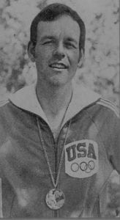 | 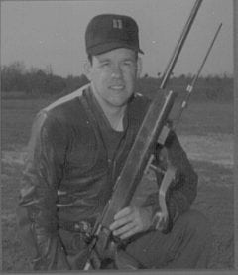
Lanny Basham
Lanny Bassham is a 1969 University of Texas at Arlington graduate who is honored for his individual achievements and international recognition in the area of small bore rifle marksmanship. During the period 1965-1969, he attended the University and participated as a member of the ROTC program. He was a leading shooter and Captain of the UTA Rifle Team. He led the team to numerous team championships and titles while he himself won All-American honors each of the four years he was at this university. He was a recipient of an Army ROTC scholarship.
Following his graduation, he accepted a commission in the Army Medical Service Corps and attended the Medical Service Basic Course at Fort Sam Houston. He was assigned to the U.S. Army Marksmanship Unit at Fort Benning, Georgia, where he built a reputation for champion style marksmanship. He consistently showed himself to be one of the top rifle shooters in the nation and the world. He was from the beginning the youngest shooter on the U.S. team. His list of accomplishments and honors won in national, world, and international competition is long and impressive. He performed as a member of U.S. Army teams at National Competitions at Camp Perry and Interservice Matches, both National and International. He consistently won positions in the CISM (Military Olympic Team). His performances took him around the world to such places as Romania, Columbia, Egypt, Moscow, Mexico City, France, Switzerland, and Montreal. In 1972, he participated as a member of the U.S. Olympic Team where he earned a Silver Medal in Small Bore Rifle Shooting. At the 41st World Shooting Championships at Thum, Switzerland, in 1974, he dominated the scene and controlled his fire for championship scores.
Captain Bassham etched his name in the memory of every nation’s rifle shooter participating in the world competition event. He was the only shooter to take three gold medals in one event and he became a whisper on the lips of every aspiring marksman. He personally earned 15 medals, eight gold, five silver, and two bronzes. In 1976, he was again a member of the U.S. Olympic team, which traveled to Montreal, Canada. This year the gold was not to elude him. He was awarded the Gold Medal for the Small Bore Rifle.
Mr. Lanny Bassham’s performance while at The University of Texas at Arlington, as a cadet in the Corps of Cadets and his subsequent achievements in the U.S. Army as a member of the U.S. Army Marksmanship Unit have brought great credit and recognition upon himself, the University of Texas at Arlington and the U.S. Army.

