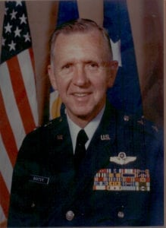 | 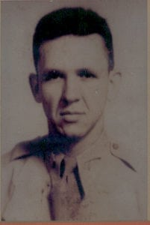
MG (Ret) Walter H. Baxter, II
A native of Weslaco, Texas, Walter H. Baxter, III was born on July 26, 1926. He attended North Texas Agricultural College, 1943-1944, enlisted in the U.S. Army Air Forces and in 1946 received an appointment to the U.S. Military Academy, West Point. In 1950, he was commissioned in the U.S. Air Force. Lieutenant Baxter went through pilot training in Texas, Alabama, and Arizona, then flew fighters in Korea, New Mexico, Virginia, and England. As a Captain, he was assigned as an instructor for the first class of the Air Force Academy. He served in the Air Training Command for a number of years, became a Major, graduated from Air Command and Staff College, and went to Germany as 22d Tactical Fighter Squadron Operations Officer for a year and was Commander for two years.
In 1970, Colonel Baxter graduated from the Army War College and went to Southeast Asia where he was Deputy Commander/Operations and Vice Commander, 8th Tactical Fighter Wing. From there he was assigned as Commander, 64th Pilot Training Wing, Reese AFB, Texas, and as Vice Commander at Keesler Technical Training Center, Mississippi, before returning to Southeast Asia as Commander, 13th Air Force (ADVON). In 1976, General Baxter commanded the 313th Air Division, Okinawa. As a Major General, he moved to command the 24th NORAD Region, comprised of 14 bases and stations located in three northern states and three Canadian provinces. Next, he served in Northern European Command as Air Deputy and Senior American Military Officer on NATO’s north flank. His final assignment was Commander, 3rd Air Fore, United States Air Forces in Europe, at RAF Mildenhall, England.
His military decorations and awards include the Distinguished Service Medal, Defense Superior Service Medal, Legion of Merit, Distinguished Flying Cross, Defense Meritorious Service Medal, Air Medal, Joint Services Commendation Medal, Air Force Commendation Medal, Air Force Outstanding Unit Award, and the Republic of Korea Presidential Unit Citation. For his service on Okinawa, he was awarded the Order of the Rising Sun by the Japanese.
In 1982, General Baxter retired to Weslaco where he took over the Walter Baxter Seed Company, founded by his father. He is active in both professional and civic affairs including the First United Methodist Church, the Weslaco Chamber of Commerce, Rotary Club (Past President), Rio Grande Valley Chamber of Commerce (Past President), American Airpower Heritage Foundation (Trustee), Texas Aviation Board, Mid-Valley Bank Board (Former Chairman), Texas Vegetable Association, American Seed Trade Association, the Rio Grande Valley Agricultural Research and Development Corporation, and the Texas Chamber of Commerce (Vice-Chairman). The General is a Trustee for the Falcon Foundation, an organization to help qualified candidates gain admission to the USAF Academy. He is also the co-founder of Citizens Against Lawsuit Abuse. He has recently been named a Marin Military Academy Trustee.
He was recognized for “dedicated service to his country and the many contributions he has made to the City of Weslaco” by the 71st Texas Legislature. In 1993 the Boy Scouts name him Outstanding Citizen of the Rio Grande Valley. In 1995 he received the Texas Vegetable Association Award of Merit for “Leadership and Outstanding Contributions to the Vegetable Industry.”
General Baxter has been solidly supported by his wife, the former Lila Waldrop. They are proud of their daughters Maurie DeWitt and Rosemary Baker, sons Bud and Scott Baxter, and grandchildren Rory Baxter, Julia DeWitt and William Baxter.His hobbies are hunting, fishing, fly-tying, and golf
During his 40 years in uniform he flew 212 combat missions and 4700 hours in 24 types of aircraft. In retirement he has become a respected member of the Texas business community.

