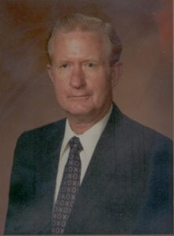 | 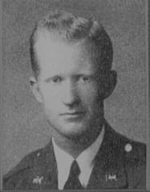
COL (Ret) Joel E. Bonner, Jr.
Colonel Joel E. “Pete” Bonner is recognized for more than 46 years of distinguished service in the Armed Forces, Federal Government, and the civilian community. He attended North Texas Agriculture College from 1939 to 1941 where he was active in the Corps and on the athletic field, participating in football, basketball, and track. After attending Navy Flight Training in 1942, he was commissioned a Second Lieutenant in the Marine Corps and designated a Naval Aviator in January of 1943. Colonel Bonner also attended Amphibious Warfare School in 1949, Command and Staff College in 1958 and received his B.S. in Military Science in 1961 from the University of Maryland.
Colonel Bonner participated in World War II, the Korean War and the Vietnam War. He received many awards including the Legion of Merit with Combat V and Gold Star, Distinguished Flying Cross, Air Medal with Seven Stars, Presidential Unit Citation, Navy Unit Commendation, and the Vietnamese Cross of Gallantry with Palm. Following the Vietnam War, Colonel Bonner was assigned to Legislative Affairs, Headquarters Marine Corps until retirement. He retired June 30, 1971 as a Colonel, U.S. Marine Corps.
Subsequent to his retirement, he held the position of Deputy Director, Office of the Assistant Secretary of Defense for Legislative Affairs. From January 1972 until May 1981, Colonel Bonner was a member of the professional staff of the U.S. Senate Committee on Appropriations. His primary responsibility was Defense Appropriations. He also became Minority (Republican) Staff Director. He was assigned Majority Staff Director for Defense Appropriations Subcommittee in January 1981. From June 1981 to August 1983 Colonel Bonner was assistant Secretary of the Army for Installations, Logistics and Financial Management. Then from August 1983 to December 1989, he was Manager of Washington Engineering Operations, Hughes Aircraft Company.
Colonel Bonner resides with his wife Joanne in Alexandria, Virginia. They have three children and two grandchildren.

