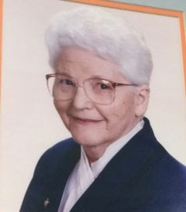 | 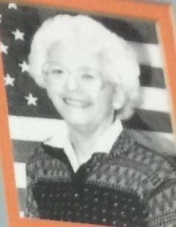

Ruth Boyd
Mrs. Boyd graduated from the University of Minnesota with a degree in Personnel Psychology. Prior to coming to the University of Texas at Arlington she worked for General Mills, Minneapolis Honeywell and Chance Vought Aircraft. After taking some time to raise her children, she returned to work in 1971 as the Membership Secretary of the First United Methodist Church of Arlington.
Mrs. Boyd came to the University of Texas at Arlington in 1978, where she worked first in Student Affairs. In 1979 she was assigned to the Military Science Department first as a university employee, then in September 1979 as a Department of the Army employee. Ruth was more than just an employee during her tenure; she was a valuable member of the cadre team, a counselor to the cadets, and a friend to all. She maintained a close personal relationship with the cadets participating in the ROTC program. Over the years she became affectionately referred to by the cadets as “Cadet Mom.” Cadets knew that they could go to her with academic as well as personal problems, and knew that she would listen and advise. As noted in the 1985 annual, “Ruth was not just a question-and- answer, push-the-paperwork individual, but one that knew each cadets record; each packet processed was an individual, a cadet.”
Mrs. Boyd served under seven different Professors of Military Science during her tenure. The cadre was constantly changing as was the directions and procedures of the ROTC program. Mrs. Boyd had to keep up with the constant personnel turnover—both of cadre and cadets—as well as the numerous administrative changes. She provided continuity and stability to the Military Science Department during these changes.
During her tenure she was responsible for the processing of over 300 cadet commissioning packets. Each of those packets was handled in a professional manner but, more importantly, in a personal way so that she shared the excitement of each cadet when they were finally commissioned. She participated in many of the events both with the cadre and the cadets.
Following her retirement in 1992, Mrs. Boyd did not end her association with the Corps of Cadets. She became an active member of the Corps of Cadets Advisory Committee and later as a member of the Corps of Cadets Alumni Chapter. Her vast knowledge of the cadets and those who were commissioned through the program were instrumental in the organization of the Corps of Cadets Alumni Chapter.
The Military Science Department and the Corps of Cadets, but in particular the cadets, were blessed by the dedication and devotion to duty shown by Mrs. Boyd during her tenure.
Ruth and her husband of 49 years, Aubrey, continue to reside in Arlington. They have two children.

