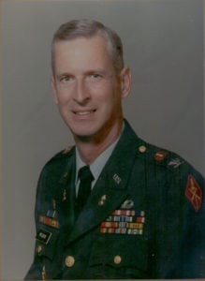 | 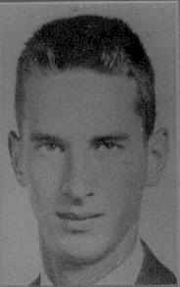
COL (Ret) Paul A. Wibur
Colonel Paul Wilbur is a 1959 graduate of Arlington State College and is being honored for his distinguished military service and professional achievements.
Colonel Wilbur was born in 1938 at Fort Sam Houston, Texas. He attended Arlington High School and, upon graduation, began his distinguished military career as a cadet at Arlington state College. He was commissioned a Regular Army Second Lieutenant in the Field Artillery in 1962 after graduating from the University of Texas at Austin as Distinguished Military Graduate. In 1964 Colonel Wilbur transferred from Field artillery to the Ordnance Corps. He holds both a Bachelors and Masters Degree in Mechanical Engineering. His military education includes the completion of the Field Artillery, and Ordnance Basic Course, Ordnance Officer Advanced Course, U.S. Army Command and General Staff College, and the U.S. army War College.
During His twenty-six year career, Colonel Wilbur was assigned to numerous significant positions at various locations in the U.S. and overseas including Vietnam, Korea, and Germany. His initial assignment was as an Artillery Battery Executive Officer at Fort Riley, Kansas, and later in Berlin, Germany. He then was assigned to Fort Campbell, Kentucky as a Maintenance Company Commander. He went on to command Maintenance Companies in Vietnam and Korea, the 782nd Maintenance Battalion ( Airborne) at Fort Bragg, North Carolina, and the 2nd Infantry Division support Command, Camp Casey, Korea, the Army’s largest Support Command. He also was assigned to several General and Department of the army Staff positions. He was a Personnel Management Officer at the Military Personnel Center, Alexandria, Virginia, Logistics Analyst for the Office of the Army Chief of Staff at the Pentagon, and division G-4, 82nd Airborne Division, Fort Bragg, North Carolina. He later was assigned as Director for Supply, Anniston Army depot, Anniston, Alabama, and Director of Material Management, Aviation System Command, St. Louis, Missouri. He also served as Assistant Professor of Mathematics, United States Military Academy, West Point, New York. He finished his distinguished career as Commandant, U.S. Army Ordnance Missile and Munitions Center and School, Redstone Arsenal, Alabama.
Colonel Wilbur’s decorations include the Legion of Merit, the Bronze Star Medal, the Meritorious Service Medal with two Oak Leaf Clusters, the Army Commendation Medal with Oak Leaf Cluster, the Army Achievement Medal, the Air Medal, the Armed Forces Expeditionary Medal, the Army Occupation Medal (Berlin), the Vietnam Service Medal, the Vietnam Campaign Medal, and the National Defense Medal. He wears the Master Parachutist Badge, the Canadian Parachutist Badge, the Vietnam Parachutist Badge, and the General Staff Identification Badge.
Colonel Wilbur is married to the former Leanne Hasty of Huntsville, Alabama. He has two children; Andy, an attorney and graduate of the University of Texas at Arlington, and Brett, an architect and graduate of Washington University, St. Louis, Missouri.

