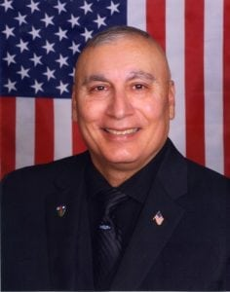 | 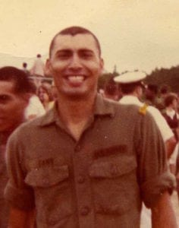
LTC (Ret) Amador (Andy) L. Cano Jr.
LTC (Retired) Andy Cano came to the University of Texas at Arlington from Corpus Christi, Texas, in 1976. He was a member of the Insurgent Team for four years and commanded the team. He completed the Army Ranger Course while a cadet at UTA. He graduated from UTA in 1980 with a Bachelor’s Degree in Physical Education. LTC Cano earned a Master’s degree in 1993 from Central Michigan University in Management, Science and Administration (MSA).
While at UTA in 1978, LTC Cano was commissioned as a Second Lieutenant of Infantry in the Texas Army National Guard and served as a Rifle Platoon Leader in A Company 1st Battalion, 143rd Parachute Infantry Regiment (PIR) 36th Airborne Brigade. LTC Cano began service on active duty in 1980 following his graduation from UTA.
LTC Cano served as a Rifle Platoon Leader, Executive Officer, and Commander of the Advance Airborne (Jumpmaster) School with the 82nd Airborne Division, at Fort Bragg, North Carolina. He deployed with the 82nd Airborne Division in support of Operation Urgent Fury to the island of Grenada in 1983. He was then assigned to the 1st Battalion, 5th Cavalry Regiment, 1st Cavalry Division at Fort Hood, Texas, where he served as the Battalion S3 Air and Rifle Company Commander. He was selected and assigned to the 1st Battalion, 75th Ranger Regiment at Savannah, Georgia, in support of national policies and objectives. Following his assignment with the Rangers, he reported to the 24th Mechanized Infantry Division, Fort Stewart, Georgia, and served as a Cavalry Troop Commander during their deployment to Desert Shield/Storm Campaign in Iraq. LTC Cano was assigned to the Center for Army Lessons Learned, Fort Leavenworth, Kansas. He participated in compiling the After Action Report and lessons for the Desert Shield/Storm Campaign.
In 1993, LTC Cano again reported to the 1st Cavalry Division at Fort Hood, Texas, where he served on the division staff in G3 operations before again being assigned to the 1st Battalion, 5th Cavalry Regiment as the Battalion Operations Officer. LTC Cano deployed with the Battalion to Kuwait as the lead contingent to reinforce the Kuwait armed forces against a potential invasion by Iraq. Upon return from Kuwait, he served at Division staff level before reporting to Fort Leavenworth, Kansas, where he was assigned as a Senior Maneuver Observer as part of the Battle Command Training Program.
In May 2000, while assigned to the U.S. Army’s Army Medical Department (AMEDD) Center and School, LTC Cano served as Chief of Tactics for the Combined Arms and Training branch at Fort Sam Houston, Texas. He retired from the U.S. Army in May 2002 and began his second career as a Senior Army Instructor for the Junior Reserve Officer Training Corps at James Madison High School in San Antonio, Texas.
In January 2006, he reported back to active duty and was assigned to the 4th Infantry Mechanized Division in Baghdad, Iraq. Fate intervened and his son, Second Lieutenant Jason Cano, was in a unit that was attached to the 4th Infantry (M) division at the same time. In 2007, LTC Cano retired a second time from the Army and returned to his Junior ROTC duties at James Madison High School. His dedicated work with his cadets resulted in over thirty of them receiving four-year college scholarships or appointments to the United States Military Academy. In 2013, he retired from his career devoted to developing leaders in the Junior ROTC Program.
LTC Cano’s awards and decorations include: Legion of merit, Bronze Star Medal (2ND Award), Meritorious Service Medal (4th Award), Army Commendation Medal (4th Award), Army Achievement Medal (3rd Award Combat Infantryman Badge, Ranger Tab, Master Parachutist Badge, and Canadian Parachutist Badge.
Andy Cano and his wife Melinda reside in Canyon Lake, Texas. They have three children and four grandchildren.

