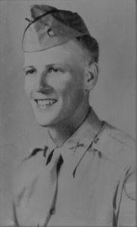 | 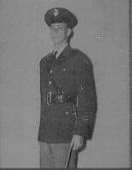
1st LT Russell Carrico
(KIA)
Lieutenant Carrico was a 1942 graduate of North Texas Agricultural College who is honored for his courageous service to his country resulting in the sacrifice of his life while serving in the U.S. Army during World War II to preserve the freedom of the United States and the world. Lieutenant Carrico was born on January 15, 1922 in San Antonio, Texas. He graduated from the Texas Military Academy prior to coming to North Texas Agricultural College in 1942. He attended NTAC from January through December 1942 and participated as a member of the Corps of Cadets. For his outstanding leadership qualities and military bearing he was selected to serve as the Corps Commander in the fall of 1942.
LT Carrico, like so many other young men in 1942, volunteered and was called into service at mid-term to begin his service in the U.S. Army. Upon entering the U.S. Army, he was sent to the Infantry Officer Candidate School at Fort Benning, Georgia. He was subsequently commissioned a 2LT in the Infantry and sent to Fort Wolters, Texas. As World War II progressed, LT Carrico was deployed to Europe with the 30th Infantry Division. His unit was actively involved in the thick of the fighting in France and Germany following the Normandy Invasion. LT Carrico saw considerable combat action while serving with Company I, 119th Infantry Regiment of the 30th Infantry Division. In September of 1944, units of the 30th Infantry Division along with other elements of XIX Corps began action to penetrate the west wall north of the key city of Aachen, Germany. The attacks to follow were significantly important and tactically difficult.
After days of bitter and intense fighting, LT Carrico’s unit found themselves in the vicinity of Uebach, Germany. The Germans made a gallant attempt to reinforce the area. At dawn on October 4, 1944, the Germans launched a counterattack. The main attack hit the center of the 119th Infantry Regiment line specifically Company I. The intense German artillery fire inflicted heavy casualties on the company, among them LT Carrico. However, before the Germans could exploit their success, the American units were able to regroup and the 119th Infantry Regiment successfully held the line. LT Carrico and other brave American soldiers that day paid the price of war with their lives.
LT Carrico was a recipient of the Bronze Star Medal, the Purple Heart, and the Combat Infantryman’s Badge. The faculty and student body of NTAC at a special tribute recognized LT Carrico’s sacrifice during the Homecoming festivities in 1946. LT Carrico’s performance while at North Texas Agricultural College as the Commander of the Corps of Cadets and the sacrifice of his life in the defense of the United States while serving in the U.S. Army brought great credit and recognition upon himself, the Corps of Cadets and The University of Texas at Arlington.

