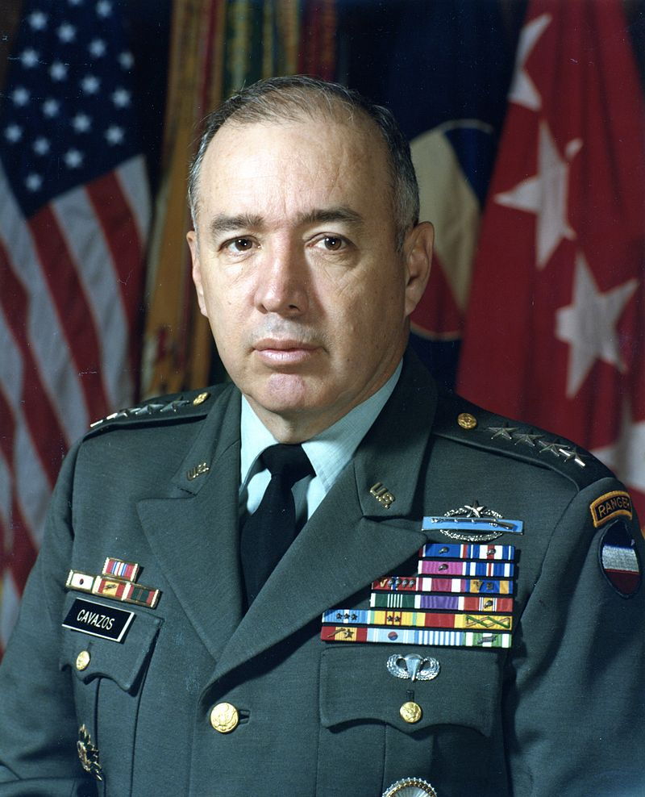 | 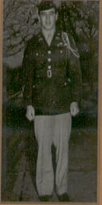
GEN (Ret) Richard Cavazos
General Cavazos is a 1949 graduate of North Texas Agricultural College who is honored for his professional achievements during a long and illustrious military career which has led him to his current rank of Lieutenant General in the U.S. Army. During the period 1947 and 1949, he attended the University when it was North Texas Agricultural College, better known as NTAC, and participated as a member of the Corps of Cadets. He was a member of the renowned Crack Drill Team, the Sam Houston Rifles. He reached the rank of Cadet Captain and served as a Cadet Company Commander.
Following completion of his ROTC training and graduation from NTAC he transferred to Texas Tech University to complete his college degree. He graduated from Texas Tech with a Bachelor of Science degree in Geology. He was commissioned as a Second Lieutenant in the Infantry as a distinguished Military Graduate. General Cavazos’ military career took him from leading an infantry platoon in combat to commanding an entire Army Corps. He began by leading a platoon and commanding a company during the Korean War. Later in Vietnam, he commanded an infantry battalion of the 1st Infantry Division. Following Vietnam, he commanded a brigade of the 1st Infantry Division at Fort Riley, Kansas, and later was the Assistant Division Commander of the 2d Armored Division at Fort Hood. He was the Commanding General of the 9th Infantry Division at Fort Lewis, Washington.
In February 1980 he was promoted to Lieutenant General and assumed command of the U.S. Army III Corps and the largest installation in the Southwest Fort Hood, Texas. In addition to the troop duty assignments, he has served on both the Department of the Army and Department of Defense staffs. He is a graduate of the Armed Forces Staff College, Command and General Staff College, Army War College and the British Army Staff College.
General Cavazos’ final military assignment was command of the U.S. Army Forces Command. “His early support for the National Training Center and his involvement in the development of the Battle Command Training Program enormously influenced the war fighting capabilities of the U.S. Army.
General Cavazos retired in 1984 after 33 years of Army service, continuing to mentor young general officers. Among his many honors, he was inducted in 1993 into Fort Leavenworth’s Command and General Staff College Hall of Fame.
He is the recipient of numerous awards and decorations. Most noteworthy is the fact that he was twice decorated with the Distinguished Service Cross, the Nation’s second highest award for gallantry in action. He also is the recipient of the Silver Star (2 awards), Distinguished Flying Cross, Legion of Merit (2 awards), Bronze Star Medal (5 awards), Air Medal, and the Purple Heart. He also proudly wears the Combat Infantryman’s Badge with Star to signify his role in combat as an Infantryman during two conflicts.
General Cavazos was honored as a Distinguished Alumni by The University of Texas at Arlington in 1975. General Cavazos’ performance while at North Texas Agricultural College as a cadet in the Corps of Cadets, and his subsequent achievements in the U.S. Army have brought great credit and recognition upon himself, The University of Texas at Arlington and the U.S. Army.
General Cavazos died in San Antonio, TX on 29 OCT 2017 (aged 88).

