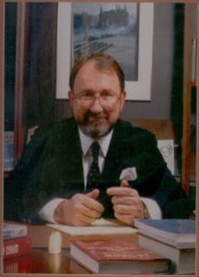 | 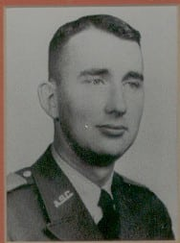
Pat Choate, Ph.D.
Dr. Pat Choate is a 1963 Distinguished Military Graduate of Arlington State College who is honored for his professional achievements during a long and illustrious career as a political economist. Upon graduation, he was commissioned in the United States Army as a Second Lieutenant and served on active duty for two years. In 1965, he transferred to the Army Reserve. While a student at Arlington State College, Dr. Choate was a member of the Corps of Cadets and was Co-Commander of Delta Company his senior year. He was active in campus politics and was a member of the Student Council for two years. Dr. Choate received his degree in Economics and was an active member of the Business and Economics Club during his years on campus. He was a popular student and his classmates selected him as one of twelve Reveille favorites in the student elections of 1962 and 1963.
During the 1960s, Dr. Choate earned his Ph.D. in Economics from the University of Oklahoma and later became Director of Planning for the State of Oklahoma and also served as an Economic Advisor to the Governor. In the 1970s, he became Commissioner of Economic and Community Development for the State of Tennessee and was responsible for organizing and administering the State’s programs for industrial development, community development, tourism promotion and worker training. Dr. Choate served as Tennessee’s representative on the Appalachian Regional Commission, the Growth Policies Board, and the Southern Interstate Nuclear Board as well as on several Presidential Commissions. He has also served as the Southern Regional Director for the Federal Economic Development Administration and in Washington as EDA’s Research Director. Dr. Choate was a Fellow at the Battelle Memorial Institute’s Academy for Contemporary Problems from 1979 to 1980. He was a senior policy analyst for TRW, Inc., during the 1980s and later became their Vice President for Policy.
As a political economist, think tank strategist, populist spokesman and author, Dr. Choate is one of America’s most widely recognized authorities on global competitiveness, management practices, and public policy. He is a familiar figure in the broadcast media of the 1990s and hosted a weekly radio talk show, The Week Ahead, that was carried on the United Broadcasting Network, a three hundred station public affairs medium, Dr. Choate co-founded in 1996. Dr. Choate is a regular guest on public and commercial broadcasting networks, including 60 Minutes, Crossfire and The Nightly News Hour With Jim Lehrer. Dr. Choate has written six books, more than three hundred articles and has delivered over two thousand speeches. In 1990, he authored the international best selling book, Agents of Influence, which brought global attention to how foreign powers try to influence United States policy. In 1993, he co-authored the book Save Your Job, Save Our Country: Why NAFTA Must Be Stopped Now with Ross Perot.
In 1996, Mr. Perot, a long-time friend, selected Dr. Choate as his Vice Presidential running mate for the Reform Party’s November bid for the White House. Dr. Choate is presently the Director of the Manufacturing Policy Project, a Washington based public policy institute and he is an Adjunct Professor at George Washington University’s School of Political Management. He and his wife, Kay, reside in Washington, D.C.
Dr. Choate’s performance while at Arlington State College in the Corps of Cadets and his subsequent achievements in public service to his country have brought great credit and recognition upon himself and The University of Texas at Arlington.

