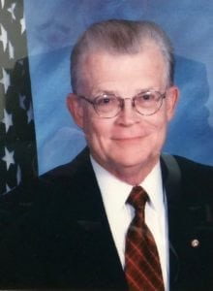 | 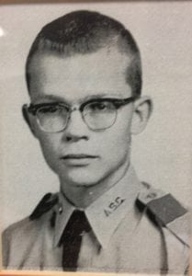

Arthur G. Cleveland, Ph.D.
Lieutenant Colonel Coughlin enrolled in Arlington State College in 1956. He graduated as a member of the college’s charter class in August 1961, with a BA in history. Upon graduation, he was commissioned a Second Lieutenant in the United States Army’s artillery branch and immediately entered active duty.
Colonel Coughlin’s career assignments included: Forward Observer, Executive Officer, and Commander of Battery A, 1st Battalion, 78th Field Artillery, 2nd Armored Division at Fort Hood, Texas; Member, Special Operations Group, Military Assistance Command in Vietnam; Senior Aide to Commanding General, U.S. Army Area Command in Germany; Secretary General Staff, U.S. Army, Berlin Brigade; Executive Officer, 4th Battalion, 9th Infantry, 25th Infantry Division in Vietnam; Director, General Staff, U.S. Army, Berlin; Commander, Battery D, 1st Battalion, 51st Field Artillery (Pershing) in Germany; Commandant of Cadets, East Central University, SROTC Program; Chief of Protocol, United Nations Command in the Republic of Korea; and Director, Doctrinal Management Division, U.S. Army Combined Arms Center in Fort Leavenworth, Kansas.
Colonel Coughlin’s military awards include the Legion of Merit, the Bronze Star Medal with “V” device and three oak leaf clusters, the Purple Heart, the Meritorious Service Medal with two oak leaf clusters, the Army Commendation Medal with two oak leaf clusters, the Air Medal with “4” device, the Republic of Vietnam Cross of Gallantry with palm, the Republic of Vietnam Honor Medal with palm, and the Combat Infantryman’s Badge. He also has the Parachutist Badge with bronze star, the Air Assault Badge, the Air Crew Member’s Badge, the Special Forces Tab, the Presidential Unit Citation, the Valorous Unit Citation, the Meritorious Unit Citation, and numerous other service and combat awards.
Upon retiring from active military service in 1982, Colonel Coughlin took the position of Senior Army Instructor of the new JROTC program at Plano East Senior High School in Plano, Texas. The unit was awarded the designation of Honor Unit in 1985, and soon attained the prestigious position of becoming an Honor Unit with Distinction, which it continues to hold today. In 1995 Colonel Coughlin became the JROTC Coordinator for the Plano Independent School District, and then the Director of Army Instruction in 2003.
Colonel Coughlin has remained in touch with the Military Science Department of the University of Texas at Arlington. He is a life member of the Sam Houston Rifles Alumni Association, a charter member of the Cadet Corps Advisory Committee, and the Cadet Corp Alumni Chapter (CCAC), a past president of CCAC, a past director of curriculum for the Military Science Department, and a member of the UTA Alumni Association’s Board of Directors.
Colonel Coughlin and his wife, the former Mary Lou (Childress) Waddell, reside in Plano. Their family includes nine children and eleven grandchildren.

