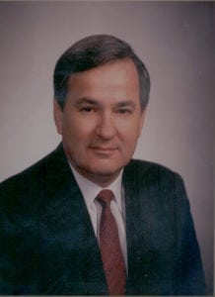 | 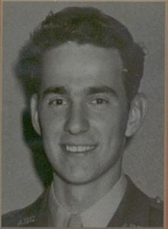
J.J. Collmer
Jan Collmer is honored for a lifetime of distinguished service to the community. He is a native of Dallas and a 1952 graduate from Jesuit High School. He is twice a graduate of this institution. He first earned an Associate of Science Degree in Mechanical Engineering in 1954 and was a member of the Corps of Cadets. He later returned to The University of Texas at Arlington and received a Bachelor of Science Degree in Mathematics in 1963.
In 1954, Mr. Collmer enlisted in the Navy, completed flight training and served as a Fighter Pilot. He departed active duty in 1958; but remained active in the Naval Reserves, NAS Dallas until 1966 and achieved the rank of Lieutenant Commander. His love for aviation continues. An accomplished aviator, he has performed stunt-flying routines at numerous air shows and is a member of the Confederate Air Force, International Council of Air Shows, Experimental Aircraft Association, and the International Aerobatics Club. He is a former Director of the Dallas/Fort Worth International Airport and currently Chairman of the DFW Airport Marketing Committee. As President of the Frontiers of Flight Museum at Love Field, he led the campaign to showcase the history of flight for the metroplex.
His contributions to the community are profound. He is the immediate Past-Chairman of the Greater Dallas Chamber of Commerce, is a member of the Board of Advisors of the International Resource Trade Center and is on the Executive Board of the Dallas Council on World Affairs. He has served in a variety of trustee and board positions in educational institutions including The University of Texas at Arlington, The University of Texas at Dallas, and the University of Dallas. A highly successful businessman, he held key positions at Texas Instruments and was President of Varo, Incorporated before starting his own company. Since 1978, Mr. Collmer has been Founder and President of Collmer Semiconductor, Inc., a Dallas electronics import, marketing, and manufacturing firm.
Mr. Collmer and his wife, Suzanne, reside in Dallas, Texas. They have three daughters, Kathryn, Sheryl and Deborah.

