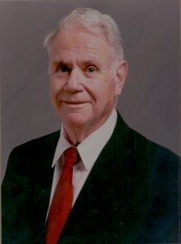 | 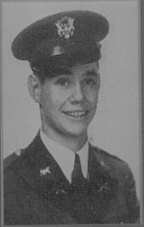
COL (Ret) Harry G. Creel, Jr.
Colonel Henry “Grady” Creel, Jr. is recognized for a lifetime of distinguished service to the military, the Fort Worth community, and the nation. He attended North Texas Agricultural College from 1938 to 1940 and completed a Bachelor of Science in Civil Engineering at Texas A&M in 1942. He was commissioned as an Engineer 2LT in the U.S. Army in May, 1942 and was ordered to active duty with the 25th Armored Engineer Battalion at Fort Chaffee, Arkansas. He served with that unit through five European campaigns as a Combat Engineer Company Commander. For his gallantry in action and meritorious service, he was awarded the Silver Star and two Bronze Stars. Captain Creel was released from active duty in December 1945, and he continued to serve his country in the U.S. Army Reserve. He culminated a distinguished 30-year career as Commandant, 4159th U.S. Army Reserve School, Fort Worth, Texas. Colonel Creel was awarded the Legion of Merit for distinguished service and retired in May 1972.
Colonel Creel has been engaged in his own business since 1965 as broker developer in land planning, commercial properties and investment building. He earned a tremendous reputation in municipal real estate development and planning and all types of civil engineering endeavors. As a consulting engineer, Colonel Creel and his firm made designs for major street, highway and land planning programs throughout North Texas. While Regional Director of Community Facilities for the Fort Worth region of the Housing and Home Finance Agency (1956-1965), he received the highest award bestowed by the HHFA for distinguished service. His citation was based on his “devotion to public service in supervising the complex and varied programs of community facilities in the region.” Serving for many years in a leadership role for the Chamber of Commerce and the City of Fort Worth, he initiated a succession of progressive military programs. Under his guidance, the Chamber became fully involved in the Operation Transition Program of the U.S. Armed Forces, designed to make the transition between the military community and the civilian community much simpler and more pleasant for the separating serviceman. His advice and counsel was sought in many areas outside the military community, and his impact will be lasting significance.
Colonel Creel resides with his wife, the former Theda Belle Waddle in Fort Worth, Texas. They have two children and five grandchildren.

