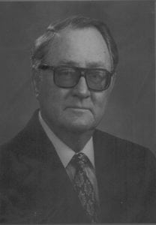 | 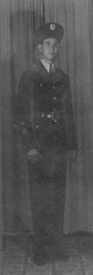
Ambassador Kennedy M Crockett
Kennedy M. Crockett was born January 18, 1920 in Kingsville, Texas. He graduated from Laredo High School in 1937. Ambassador Crockett attended North Texas Agricultural College, Arlington, Texas from 1937-1939. He was a member of the Cadet Corps during those school years. He majored in Pre-Law and was a member of the International Relations Club. Crockett won the intramural middleweight championship in 1939.
In the fall of 1939, he entered The University of Texas at Austin. There he majored in Latin American Government and History. He entered the United States Foreign Service in 1943. His first job was as clerk and Vice Consul in Nuevo Laredo, Mexico. Crockett advanced steadily in the Foreign Service nearly always being among the youngest five percent of his class at the time of promotion. As he went up through the Foreign Service ranks he held jobs which included: Vice Consul, United States Embassy, Mexico City, Mexico; Consul and Principal Officer, American Consulate, Tampico, Mexico; First Secretary and Chief of the Political Section, United States Embassy, Guatemala City, Guatemala; and Director, Office of Caribbean Affairs, Department of the State and Agency for International Development, Washington, D.C.
Later, as a relatively senior Foreign Service Officer he was ready for still more responsible tasks. In 1965, he was appointed Director of the Dominican Republic crisis in which United States had to intervene with troops. In this position, Mr. Crockett was on constant call to the Oval Office in the White House and to all other high levels of our Government. For his extraordinary duty in a crisis environment, Mr. Crockett received the Department of State Superior Honor Award, “For superior service and untiring devotion to duty during the crisis in the Dominican Republic, from April to September 1965. His sound advice and good judgment in matter of both policy and operations reflect great credit on the Department of State and the United States Government.”
Following this Task Force service, he was appointed as Deputy Chief of Mission (the second in authority) in the United States Embassy, San Jose, Costa Rica. He served in this assignment until 1967. In 1967, the President appointed Kennedy McCampbell Crockett to be United States Ambassador to Nicaragua where he served until April 30, 1970. It was from this most prestigious post that Ambassador Crockett retired from public service. Since “retirement” he has served as a consultant, cattle rancher and writer. He resided in Salona Beach, California.
From his beginnings as a cadet at NTAC, and throughout his adult life in his nation’s service, Ambassador Crockett, having reached the highest point in our Government’s foreign service is a true credit to The University of Texas at Arlington, the UTA Corps of Cadets, and the United States of America.

