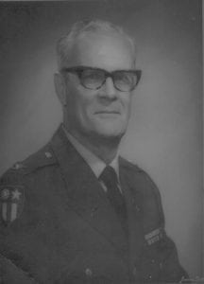 | 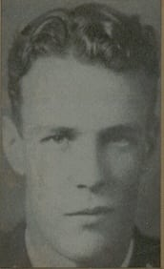
COL (Ret) Earl O. Cullum
Colonel Earl Owen Cullum began his distinguished military career as an ROTC Regimental Commander in 1930, the highest-ranking JROTC Cadet in the Dallas School System. He was born in San Antonio, Texas in 1913, was raised in Dallas, where his family had been established since 1873, and attended North Dallas High School. Colonel Cullum attended North Texas Agricultural College (NTAC) from 1932-33, transferred to Texas A&M, and later received his LLB degree from Blackstone School of Law in Chicago.
Colonel Cullum was commissioned a 2nd Lieutenant in the Infantry Reserve in 1937. He entered on active duty in1941, serving as an instructor at the United States Army Military Police School from 1942-43. He became a Staff Officer to General “Vinegar Joe” Stilwell from 1943-44 and then commanded the 159th Military Police Battalion in the China-Burma-India (CBI) Theater. At age 30 he was the youngest Military Police Battalion Commander in World War II. Following the war, he served as Security Officer at the United States Army Guided Missile Center (now NASA). After reverting to Reserve status, he was promoted to Colonel in 1975, with less than 20 years total service.
Colonel Cullum’s long and distinguished military career ended with his retirement in 1967 after more than 30 years of service. The bravery and devotion to duty of this outstanding soldier and commander has been recognized by numerous decorations and awards to include the Bronze Star Medal, China War Memorial Medal and British Burma Star Medal. Colonel Cullum served more than 800 consecutive days overseas before returning to the United States in late 1945. A graduate of the United States Military Police School, Command and General Staff College and the FBI Academy, Colonel Cullum served his country for 30 years as an Agent of the Federal Bureau of Investigation from1947-77.
He also tirelessly dedicated time to his community serving as President of the Rotary Club of Dallas, Dallas County Pioneer Association, and Reserve Officers Association; as National Commander, China-Burma-India Veterans Association; as Texas Department Commander of the Military Order of World Wars; and as Director, Greater Dallas Crime Commission; with life-time memberships in the Reserve Officers Association, Retired Officers Association and Veterans of Foreign Wars. By his dedication and exemplary action in both peace and war, Colonel Column has brought honor and distinction to himself, The University of Texas at Arlington and the United States Army.

