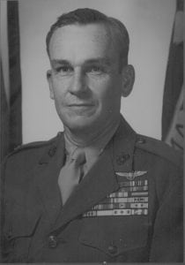 | 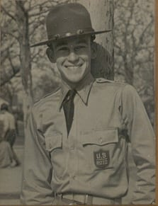
COL (Ret) Marion C. Dalby
Marion C. Dalby graduated from North Texas Agricultural College in 1942 and is honored for his long and illustrious military career. Colonel Dalby was commissioned a Second Lieutenant, USMCR, and designated a Naval Aviator on November 16, 1942. Following flight training, he joined Marine Torpedo Squadron-232 and flew torpedo bombers from bases in the New Hebrides, Guadalcanal, New Georgia, and Bouganville in the South Pacific. He returned to the United States in April of 1944 and served in a Marine Dive-Bombing Squadron until October when he was assigned to the office of Pan American Affairs, office of the Chief of Naval Operations. For combat duty during that period, he received the Distinguished Flying Cross with two Gold Stars, one citation of which reads in part, “…In an assault against shipping in the strongly fortified harbor of Rabaul, he braved fierce and determined fire from hostile ships, gun emplacements and fighter planes, and relentlessly driving home his attack to a perilously low altitude, scored a direct hit on a large cargo vessel leaving it in a sinking condition.”
After World War II, he attended several specialty schools and in June of 1948, he was assigned to guided missile training at the Naval Air Missile Test Center, Point Mugu, California. Commanding the Marine Guided Missile Unit, he and his group conceived and hand built the MPQ-14 all-weather bombing system, which became the standard Navy-Marine night and all-weather air-support system for combat air operations in the Korean and Vietnam Wars.
From 1952 to 1960, he served in a variety of flight assignments to include squadron commander on two separate aircraft carriers. In September 1961, he was assigned to the Joint General Staff of the Vietnamese Armed Forces in Vietnam where he headed a number of special projects related to guerrilla warfare and the Vietnamese Junk Force. Following his tour in Vietnam, he attended the Armed Forces Staff College and in July of 1963 was assigned to the Joint Chiefs of Staff in the Office of Counterinsurgency and Special Activities where he was Vietnam Desk Officer. He was promoted to Colonel during that assignment. In 1966, he was transferred to the Fleet Marine Force, Pacific, in Hawaii where he served as Director of the Headquarters Command Center. Returning to Vietnam in March 1968, he was assigned as Chief of Staff, Task Force Hotel, Third Marine Division at Khe Sanh Combat Base and later at Vandergrift Combat Base. Later, Colonel Dalby was assigned to the Third Marine Amphibious Landing Force in Da Nang where he served as Deputy G-3.
In May 1969, he returned to the United States and was assigned as Senior Marine Corps Liaison Officer to the Chief of Naval Operations and subsequently served on the staff of the Secretary of the Navy. He retired from the Marine Corps in 1970 and joined a Washington, D.C. consulting firm specializing in maritime cargo handling and naval logistics.

