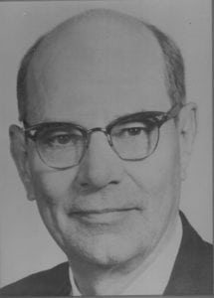 | 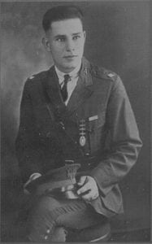
H.A.D. (Hoss) Dunsworth
Mr. “Hoss” Dunsworth is a 1922 graduate of Grubbs Vocational College who is honored for his achievements as a cadet, but most notably during a very long, successful and illustrious professional career as a member of the faculty of The University of Texas at Arlington. This service was culminated upon his retirement in 1972 after 47 years as a member of the faculty and over 51 years association with the University.
Mr. Dunsworth was born in 1902 in the Collin County community of Moreland. He graduated from high school in 1920 after attending two years at what was then a sub-college of Grubbs Vocational College. He entered Grubbs Vocational College and graduated in 1922. In 1922, as a Major and the ranking cadet, he became the Corps Commander in the Corps of Cadets. In addition, he played football as both a quarterback on offense and a tackle on defense. He also played baseball. It was from playing baseball that he earned his nickname “Hoss”. It is said that he sounded like a horse running down to first base.
Following graduation from Grubbs, “Hoss” immediately began his teaching career at Frisco, Texas. He began teaching with only two years of college and was 20 years old. He earned his Bachelor of Arts degree in 1925 from North Texas State University. He applied for and got a teaching position at his alma mater in 1925. “Hoss” was the first alumni of the college to ever be hired as a member of the faculty. He spent his first year teaching high school physics and chemistry. In 1926, he was assigned to the Math Department where he remained for the next 47 years. In addition to teaching, “Hoss” was very active in coaching. From 1927 to 1940 he coached football, track and some baseball. He was the Athletic Director and Head of the P.E. Department from 1935 to 1940. All this was to end in 1940 when “Hoss” became the “Acting” Head of the Math Department. During the War, “Hoss” served from 1943 to 1946 in the Army Air Corps as a ground school instructor in meteorology. He served at Aloe Field, Perry field, and Foster Field and achieved the rank of Captain.
He was released from service in 1946 and returned to his duties on the faculty at North Texas Agricultural College. In 1942, he was officially appointed as the Head of the Math Department where he served until 1967 at which time he stepped down from the administrative position. He continued to teach until 1972 when he officially retired. With all the hats he wore – coach, administrator and above all, teacher, “Hoss” Dunsworth believed first and always in the welfare of his students and dedicated his life to molding their minds, their bodies and in many instances, their lives.
In addition to serving UTA, “Hoss” served his community well. He was President of the Arlington Chamber of Commerce from 1951-1956 and was on the City Council for ten years, four of which were as Mayor Pro-Tem. He was a Shriner and held every high office in the Arlington Masonic Lodge. He represented Arlington on the Dallas/Fort Worth Area Development committee; was a member of the West Texas Chamber of Commerce; was a founder and member of the first Board of Directors of the First City National Bank; was a member of the Optimist Club and served on the Board of Directors for five years; and was a member of the Arlington Rotary club for over 24 years. “Hoss” was presented a Distinguished Service Award by UTA in the 1969 commencement exercises and was presented the Distinguished Alumni Award in 1970. He helped found both the Ex-Letterman’s Club and the Maverick Club and served as president of both organizations. He twice headed the UTA Alumni Association and served on the Board of Directors. He was honored as Professor Emeritus in 1972. “Hoss” died on March 22, 1981.
“Hoss” Dunsworth’s performance while at Grubbs Vocational college as a Cadet in the Corps of Cadets, his achievement and recognition while serving on the faculty of The University of Texas at Arlington, and his contribution to the city of Arlington has brought great credit and recognition upon himself, the Corps of Cadets and The University of Texas at Arlington.

