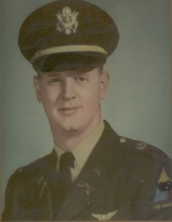 | 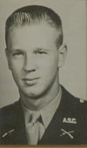
LT Dennis B. Easley
(KIA)
Lieutenant Dennis B. Easley was a 1965 graduate of Arlington State College. He is honored for his courageous service to his country, which resulted in the loss of his life while serving in the U.S. Army in Vietnam. Lieutenant Easley served two years in the U.S. Navy prior to entering Arlington State College where he became a battalion commander in the Corps of Cadets.
Lieutenant Easley was commissioned in 1965 and after completion of flight training was assigned to the 15th Medical Battalion, 1st Cavalry Division (Airmobile) in Vietnam. Lieutenant Easley distinguished himself quickly as a skilled pilot and earned the respect of his crewmembers and his fellow pilots. Lieutenant Easley was flying a night medical evacuation mission on 20 July 1966 when he crashed near An Ky, Vietnam. Lieutenant Easley became the first soldier from Arlington, Texas to give his life in Vietnam. His fellow soldiers in Vietnam, the Corps of Cadets at Arlington State College, and the city of Arlington duly honored him in a memorial service.
Lieutenant Easley’s awards and decorations include the Air Medal, the National Defense Service Medal, the Republic of Vietnam National Order Medal 5th Class, the Republic of Vietnam Gallantry Cross with Palm, and the Republic of Vietnam Campaign Medal.
Lieutenant Easley’s performance while a member of the Corps of Cadets at Arlington state College and his giving of the ultimate sacrifice, his own life, for his country while serving in the U.S. Army in Vietnam is in the highest traditions of the patriotism of the U.S. Army fighting man, the Corps of Cadets, and The University of Texas at Arlington.

