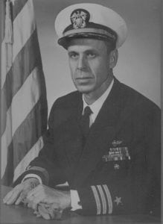 | 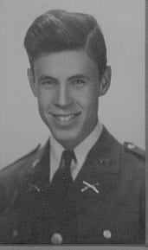
CMDR (Ret) Arthur G. Elder
Commander Arthur G. Elder attended North Agricultural College in 1939-1941 and is honored for his professional achievements during his illustrious careers in the U.S. Navy and the U.S. State Department. During the School years 1939-1941, he attended the university when it was North Texas Agricultural College, better known as NTAC and participated as a member of the Corps of Cadets. As a cadet, he was one of the early participants of the flight-training program offered by the university. Immediately upon graduation, he volunteered for the Flight Training Program with the U.S. Navy. He received his Naval flight training at Dallas and Corpus Christi, Texas.
After completion of flight training in 1942, his initial assignment was to VP-54, a patrol squadron in which he flew PBY’s in the South Pacific. In January 1945, he was assigned to Patrol Bombing Squadron 117. The squadron was known as the “Blue Raiders” because of the blue B-24, Liberator, they flew. It was while assigned to PB-117 that Commander Elder earned the Navy Cross for action on 25 March 1945. The citation in part reads: “For extraordinary heroism as patrol plane commander for action against enemy Japanese fleet units at Sargen Harbor. A courageous and aggressive pilot, highly skilled in the tactics of aerial warfare, LT Elder flew in over the area in bold deviance of terrific anti-aircraft fire sent up from armed merchant vessels and warships in the harbor, and plunging relentlessly on his assigned targets, dropped his bombs and made his devastating strafing runs at perilously low altitudes to account for three merchant vessels and the inflection of damage on two destroyer escorts and twenty other merchant vessels. Jumped by an intercepting hostile aircraft during the furious action, he promptly maneuvered to strike and, pressing home his attack with deadly accuracy, succeeded in blasting it from the sky in flames.” In this action, he sank 14,500 tons of shipping.
In June 1945, Lt Elder and his five-man crew were named as the Navy’s ace liberator pilot and crew in terms of Japanese shipping destroyed or disabled by a single plane. During just a three-month period over the Southwest Pacific and South China Sea, they sank 25,900 tons and damaged 42,495 tons of enemy shipping for a total of 68,395 tons.
Following the war, Commander Elder remained in the Navy becoming qualified in photo interception and the intelligence field. His training as a naval aviator saw him go from flying patrol planes to becoming Operations Officer of a carrier-based, heavy attack squadron. He served as Director of Flight Training and Operations in carrier qualifications of student pilots; Planner on the staff of the Chief of Naval Air training; Assistant Director of Atlantic Fleet Heavy Aircraft Operations; and, Commander of an Electronic Intelligence Squadron in Spain.
In 1965, he retired from the U.S. Navy upon completion of a tour as Deputy Chief, Reconnaissance Division, Defense Intelligence Agency. After retirement, he worked in aviation, intelligence and logistics assignments with USAID, Office of the State Department in Thailand and South Vietnam. Today he resides in San Diego, California. Commander Elder’s awards include the Navy Cross, Distinguished Flying Cross with four stars, Air Medal and the Purple Heart. For his service with the USAID in Thailand, he was awarded a Companion of the Most Exalted Order of the White Elephant by the government of Thailand.
Commander Elder’s performance while at North Texas Agricultural College in the Corps of Cadets and his subsequent achievements in the U.S. Navy brought great credit and recognition upon himself, The University of Texas at Arlington, the Corps of Cadets and the U.S. Navy.

