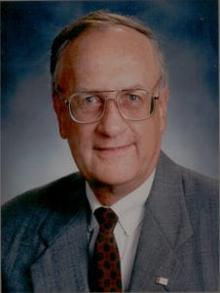 | 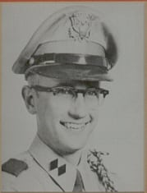
COL (Ret) Charles E. Feuerbacher
Colonel Feuerbacher is a 1961 Distinguished Military Graduate of Arlington State College (ASC) who is honored for his student, military and professional achievements. Following his graduation from North Dallas High School, Colonel Feuerbacher entered Arlington State College and earned a Bachelor of Business Administration Degree. He was a member of the Corps of Cadets throughout his period and had the distinction of holding the rank of Cadet Colonel and Corps Commander twice, once in his sophomore year when ASC was a junior college and again in his senior year after the University obtained four-year accreditation. While at ASC, he won the McNight Scholarship award in 1958, was a member of the Student Council, served as President of his Sophomore Class, was a four-year letterman of the Rifle Team and was elected to the All-American Rifle Team in 1960 (the first All-American in any sport at the new four-year school). In addition, in 1960, Colonel Feuerbacher captured the title of Texas State Small Bore Rifle Champion. As a member of the first senior class of Arlington State College, he was one of seven Second Lieutenants to be commissioned in 1961.
Early in his military career, Colonel Feuerbacher competed on the Army Rifle Team in military and international rifle matches. During this period, he enjoyed perfecting skills learned in ASC’s ROTC program as he taught rifle marksmanship on college campuses through the United States. His marksmanship awards included the Distinguished Rifleman Badge and the President’s Hundred Tab. After serving for several years in the Infantry, Colonel Feuerbacher branch transferred into the Finance Corps and served for five years in unique assignments, including Financial Advisor, CORDS, MACV HQS. After completing a tour in Vietnam, Colonel Feuerbacher transferred to the Medical Service Corps and served his remaining eighteen years in the military working in budget, management and financial areas of health care. He worked at Walter Reed Army Medical Center, Tripler AMC, and Brooke AMC. In 1978-80, he was assigned as Medical Service Corps Officer on the Comptroller of the Army’s Staff in the Pentagon. He also served as the Chief of Resource Management, Academy of Health and Sciences, and Chief, Program and Budget Division, United States Army Health Services Command. After twenty-six years of service, Colonel Feuerbacher retired in 1987.
Fulfilling a lifetime dream of becoming a Texas banker, Colonel Feuerbacher transitioned to the civilian sector as Vice President, Corporate Trust, NationsBank of Texas. His Army work experiences and the Masters of Business Administration he earned from Syracuse University in 1971 eased his move into civilian life. He is now employed by Texas Commerce Bank as President of Global Trust Services in the Austin Office. He has earned the distinction of being awarded the Certified Corporate Trust Specialist by the Institute of Certified Bankers.
Colonel Feuerbacher has received numerous military awards and decorations, including the Legion of Merit. He is involved with his church and works with junior high-level youth and with the Austin Men’s Bible Study Fellowship Class. He has a continued interest in the welfare of children and has served on the board of South Texas Children’s Rehabilitation Center in San Antonio, Texas. Colonel Feuerbacher, is married to his college sweetheart, Priscilla Cooper of Arlington. They are the proud parents of two sons, Charles, Jr. and Brent.

