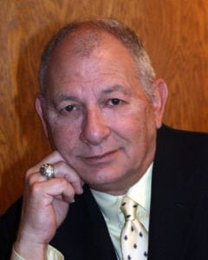 | 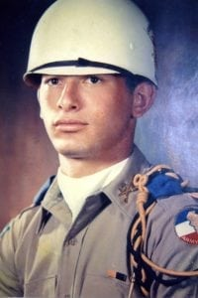
Allan N. (Bunky) Garonzik
Allan graduated from Highland Park High School in 1961. He entered Arlington State College and was a member of the first graduating class of the renamed University of Texas at Arlington, receiving his BBA in 1967. Later that same year he attended the Tulane Graduate School of Business in New Orleans.
While a cadet at UTA, Allan was a member of the Sam Houston Rifles Drill Team and a Cadet Captain and Battalion staff member, and a staff member for both the Shorthorn, the UTA student newspaper, and the Reveille, the college annual.
Allan served as a Captain in the Military Police of the Texas Guard for six years, and later obtained a “Secret” clearance and was recruited by LTV, where he purchased classified military parts for Navy fighters and bombers. Allan later worked as a supervisor for Long John Silver’s Seafood restaurants, eventually opening and managing 27 units over a four-state area.
In 1970, Allan opened Ready Print, a small printing and graphic arts company. Over the next ten years, he opened six more Ready Print shops. In addition to the print shops, Allan invented and manufactured a piece of printing equipment, selling over 1,000 units throughout the United States. While maintaining these businesses, Allan started a Penske truck rental agency, managed Louann’s nightclub on the weekends, became partners in a real estate company, and for nine years was the Director of Operations for the Grand Prix of Dallas. Allan is currently a Handgun Instructor for the Texas Department of Public Safety, and part owner of Red’s Patio & Grill Restaurant.
Allan has had a pilot’s license since 1967. He is a certified SCUBA diver, a certified SCCA race car driver, and is certified as a Wood Badge Boy Scout adult leadership trainer.
For 22 years, Allan was a member of the Chili Society, and served as its chairman. This organization raised over $750,000, which was donated directly to leukemia research. Allan also served as the coordinator for the Chili’s Restaurant 10K run and Chili Cook-off benefiting the North Texas Food Bank. He also worked as a volunteer for the Red Cross in their pet-rescue program after Hurricane Katrina.
Allan helped form the Sam Houston Rifles Alumni Association; he served for four years as President, and then as Editor for 20 more years. He helped create his neighborhood homeowners association and served as President. Allan created the Texas Handgun Instructors Association, and then served as President representing some 3000 instructors. He is a member of the Board of Directors of Highland Park High School Alumni Association, and is currently a member of the Executive Board of the Cadet Corps Alumni Council.
Allan and his wife Sandra live in Argyle, Texas. Allan did most of the construction on his house himself. He has two children, and four grandchildren. His hobbies include motorcycles, writing, skydiving, antique restoration, old cars, and gardening. Allan has attended every UTA Homecoming since his graduation in 1967.

