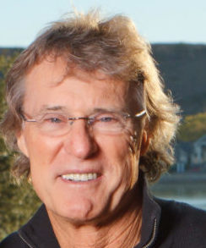 | 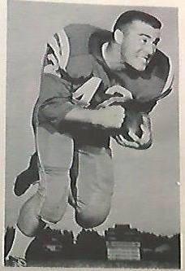
LTC (Ret) Michael R. Greer
Michael Roberts Greer was born in Chanute, Kansas, December 16, 1938, and soon moved to Texas, settling in Littlefield, Texas. Michael graduated from Littlefield High School in 1957. During his adolescent years he was very involved with his church and Boy Scout activities where he was awarded the prestigious “God and Country” award. While growing up in Littlefield, Texas he was very active in two sports, football and track. During his high school football career, he was the starting running back for the Wildcats each year until graduation in 1957 and was co-captain for the 1956 football team. He also competed in high school track as a sprinter. He accepted a full athletic scholarship to play football at the University of Houston, where he also ran track for the national undefeated track team of U of H. After spending two years at the University of Houston, Michael decided to transfer to Arlington State College where he had initially been recruited by Coach Chena Gilstrap. After 3 workouts with the ASC team, he was offered, and accepted, a full 3-year scholarship to play football. He also ran track in the spring and became a two-sport letterman for the Rebels. Michael was elected team captain of the track team his senior year. The transfer to Arlington State gave him a chance to focus on his education, plus continue his goal to receive a commission in the US Army by enrolling in ROTC. Michael served as the Cadet Battalion Executive Officer in ROTC his senior year. He graduated with a BBA from Arlington State College and was commissioned in the US Army in 1963.
Michael entered active duty at Ft. Riley, Kansas with the 4th Armored Calvary as a Platoon Leader in Bravo Troop, 1st Infantry Division. Under LT Greer’s leadership, the First Platoon distinguished itself by excelling in readiness exercises resulting in LT Greer being selected as commander of Troop B. Upon completion of an outstanding troop command Michael returned to civilian life and entered the business world and became an industrial packaging innovator for the cotton industry. This led him to the material handling side of the cotton industry with new innovations for both handling and packaging. Additionally, he created a multi-sport event production company. He created 50 triathlon events in 8 cities with the cornerstone event, Ironman70.3 Lubbock, that became a world recognized event now entering its 30th year. He also joined the US Army Reserves and served as the Commanding Officer of the 413th Civil Affairs provisional Civil Affairs Company in Lubbock, Texas. Later CPT Greer became the commanding officer of Co B, 980th Engineers for four years. After being promoted to Major he was reassigned to the 414th Civil Affairs. MAJ Greer was then promoted to Lieutenant Colonel and served as the G5 Civil Affairs staff officer for the 2nd Armored Division in Patterborne, Germany during a combined exercise in Europe.
In 1992, Michael earned his PhD as a Doctor of Philosophy from LaSalle University. He later became certified in the following fields: legal mediator, life coach, emotional intelligence and parenting coordinator. He served on 6 nonprofit boards and was elected to board president on 4 of these boards. He also authored 3 books: “Mind Management”; “11 Points of Healthy Ageless Living”; and the “Triathlon Guidebook”.
As a lifelong athlete Michael continued to compete in the sport of triathlon at the age of 44. After 35 years of competition he was able to complete his 400th triathlon on September 23, 2018. He was elected to the Texas Triathlon Hall of Fame in 2009 and the SMW Hall of Fame in 2011. He has also been nominated for the 2019 USA Triathlon National Hall of Fame.
The highlight of his military career was his commissioning at Arlington State College into the US Army as a 2LT and the swearing in of his son and nephew as Lieutenants in the US Army. Both are currently Lieutenant Colonels and have each served in 3 war zones.
LTC Greer currently resides in Ransom Canyon, Texas with his wife Marti. They have 5 grown children, 15 grandchildren, and 4 great grandchildren.

