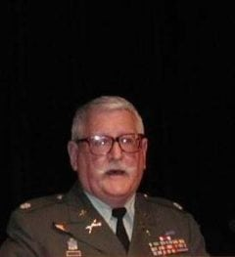 | 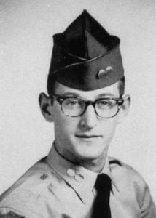

LTC (Ret) William H. (Buck) Herndon, Jr.
Lieutenant Colonel William H. Herndon, Jr. (AUS-RET) graduated from Midland High School in May 1956 and enrolled at Arlington State College (ASC). He received a BS degree in biology in 1961 and has BS and MS degrees in geology from Texas Christian University.
In 1955, Mr. Herndon enlisted in the U.S. Marine Corps Reserve and, upon enrollment at ASC, he joined the Army ROTC. He was a member of the Sam Houston Rifles. During his sophomore year he was A Company executive officer and Corps S-4. He also served as Corps executive officer, S-2 and C Company commander. At ASC he was a member of the pre-medical and geological societies. In 1964, he was accepted into Sigma Gamma Epsilon, the National Honor Society of Geologists, Metallurgists, and Mining Engineers.
Commissioned in 1961, he was one of the first officers to be commissioned from ASC after it became a four year college. He served two years in the Transportation Corps as a platoon leader, company maintenance officer, and executive officer. On leaving active duty he joined the 144th Infantry, Texas National Guard and served as a weapons platoon leader in Arlington and in the S-3 Section in Fort Worth. In 1966 he transferred to ODB3 Co C 12th Special Forces Group (USAR) and served as S-4 in Fort Worth. With Co A 2nd Bn 12th SFGA in Oklahoma City, he served as an A Detachment commander and S-2, and when promoted to MAJ in 1976, was attached to 2nd Bn HQ in Tulsa.
He transferred to the inactive reserve in 1980, and was promoted to LTC in 1983 while serving as an Individual Mobilization Augmentee at Fort Hood. Prior to his retirement in 1989, he served as the Reserve Affairs Officer, U.S. Army Logistics Center in Fort Lee, Virginia. His primary duties were to program, budget, and monitor active duty tours of Individual Reservists in support of LOGEX, the NATO logistics exercise held annually at Fort Pickett. Mr. Herndon has completed the Transportation and Armor Officers’ basic courses, the Infantry Officers’ Advanced Course, Airborne, Jumpmaster, the SF Officers’ Course, and the Parachute Maintenance and Airdrop Officers’ Course. He is a graduate of the Logistics Executive Development Course, and the Reserve Component Command and General Staff Officers Course. His awards include Master Parachutist Badge, Parachute Rigger Badge, and SF Qualification Tab. He was a member of the Armor Association, National Guard Association and the Reserve Officers Association.
As a geologist, Mr. Herndon worked in the petroleum reservoir engineering business for Core Labs, Inc. in Dallas. In 1972 he joined Compucon, Inc. His projects included the layout and survey of the MCI network and the ITT network that starts in Houston and ends in New York City. He was also involved with the location and survey of the receiver sites for the HBO system. In 1981 he was an exploration geologist for Ralph Lang Petroleum Consultants in Fort Worth before becoming an independent consultant. His professional affiliations included the Fort Worth Geological Society and the American Association of Petroleum Geologists. After his retirement from the USAR he worked for TXDOT. He retired in 1998 and presently deals in military memorabilia.
Mr. Herndon lives in Fort Worth and is a member of American Legion Post 626. He has two grown children. His daughter, Sydney, lives in Dallas and his son, Chris, lives in Bedford.

