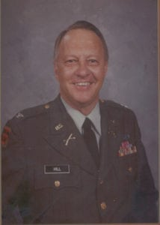 | 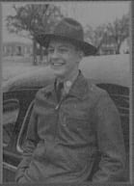
COL (Ret) Joe M. Hill
Colonel Joe M. Hill, United States Army, began his military service as a cadet at North Texas Agricultural College from 1941-43 and retired as a Colonel in the Army Reserve. Born in 1923 in Dallas, Texas, Colonel Hill graduated from North Texas Agriculture College with his Associates Degree in 1943. In January 1943, he entered the United States Army as a private, was assigned to the 84th Infantry Division and later, as a Corporal, was selected to go to Infantry Officer Candidate School. Upon graduation, he received his 2nd Lieutenant commission and was assigned to the 103rd Infantry Division. In October 1944, the 103rd joined the Seventh US Army in Southern France with Colonel Hill serving as an Infantry Platoon Leader in the European Campaign to its conclusion. He was awarded the Combat Infantryman’s Badge, the Bronze Star for meritorious service, the European Medal with two Bronze Stars, the American Defense Medal, and the Victory Medal. He served in the Army of Occupation until June of 1946.
Upon returning to the United States, he continued his education obtaining a BBA Degree from Southern Methodist University. He continued his Army career as a Captain in the 90th Infantry Division in the U.S. Army Reserve, until called to active duty when the Korean Conflict began. Colonel Hill served as an instructor in the JROTC program for two years and enjoyed this position so much that, when released from active duty again, he became the first Senior Army Instructor at South Oak Cliff High School in Dallas, teaching ROTC for Dallas Area High Schools for 31 consecutive years.
As a teacher in the ROTC program, he has received many awards. He received the Freedoms Foundation Medal, in 1972 was nominated for National Teacher of the Year in 1981, and was selected Teacher of the Year in the Oak Cliff High Schools in 1982. Colonel Hill continued to serve in the U.S. Army Reserve in various capacities attaining the rank of Colonel. His last assignment was Commandant of the U.S.A.R. School where he was responsible for the schooling os come 800 officers and 400 enlisted men. He received the Legion of Merit for his outstanding accomplishment with that unit. Colonel Hill was inducted in the Officer Candidate School Hall of Fame at Fort Benning, Georgia in 1991.
Colonel Joe M. Hill was inducted in the Hall of Honor, Military Science Department at The University of Texas at Arlington in February of 1994 in recognition of his achievements and contributions to the country. His beginning as an ROTC cadet and his rise to heights of responsibility and prestige provide an example and incentive for all future officer graduates from the campus at Arlington.

