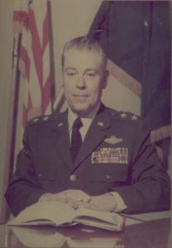 | 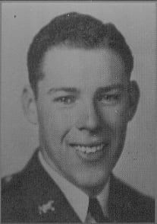
MG (Ret) John R. Hinton
Major General Hinton attended North Texas Agricultural College (NTAC) from 1940-1942 and is honored for a long and distinguished military career in the U.S. Air Force. General Hinton was born in Crawfordsville, Arkansas, and attended high school in Grand Prairie, Texas, where he graduated. After attending NTAC, Hinton entered the Army Air Corps in February 1943 as an aviation cadet and subsequently received his pilot wings and commission as a Second Lieutenant in April 1944. He completed his B-26 transition training at Laughlin Field, Texas.
During World War II, General Hinton served as a B-26 pilot with the 397th Bombardment Group of the 9th Air Force in France and Holland. He flew 35 combat missions with 135 combat hours in the European Theater. In July 1946, he returned to the United States and was released from active duty into the Air Force Reserve as a Captain. In May 1948, he returned to active duty and served as Squadron Commander at Bolling Air Force Base, Washington, D.C., until 1951 when he entered the University of Maryland. He earned his Bachelor of Science degree and then was assigned to Naples, Italy as an Operations Staff Officer with the Commander in Chief, South (NATO). General Hinton completed Air Command and Staff School at Maxwell Air Force Base, Alabama in 1955 and went on to B-29 and C-97 transition training. He was assigned to the 310th Bombardment Wing of the Strategic Air Command of the 28th Air Refueling Squadron, Commander of the 77th Bombardment Squadron, Deputy Commander for Operations of the 28th Bombardment Wing, Deputy Base Commander of March Air Force Base, California, Chief of Operations Plans Division, and later Assistant Deputy Chief of Staff for Operations at Headquarters, Fifteenth Air Force.
During the Vietnam conflict, General Hinton served as Commander, 307th Strategic Wing at U-Tapao Thai Air Force Base, Thailand with responsibility for all B-52 and KC-135 aircraft based in Southeast Asia in support of the Seventh Air Force and the Military Assistance Command Vietnam (MACV). He flew 42 combat missions and logged over 300 flying hours in B-52 and KC-135 aircraft. Upon his return, General Hinton assumed duties as the Chief of Staff, Fifteenth Air Force, March Air Force Base, California. He was appointed Inspector General of the Strategic Air Command in 1973 after he returned to the Fifteenth Air Force as Vice Commander.
General Hinton retired on 30 May 1975 after more than 32 years of military service. His awards and decorations include the Distinguished Service Medal with Oak Leaf Cluster, Legion of Merit with Oak Leaf Cluster, Distinguished Flying Cross, Air Medal with eight Oak Leaf Clusters, Air Force Commendation Medal with seven Oak Leaf Clusters, Distinguished Unit Citation Emblem, Air Force Outstanding Unit Award Ribbon with three Oak Leaf Clusters, Good Conduct Medal and the Vietnamese Cross of Gallantry with Palm. Major General Hinton’s dedicated and exemplary service to his country bring credit upon himself, The University of Texas at Arlington, and The United States Air Force.

