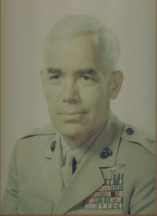 | 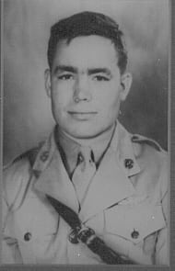
BG (Ret) William H. (Hank) Hise
Brigadier Henry W. Hise, United States Marine Corps, who flew combat missions in three wars, began his distinguished military career as a cadet at North Texas Agricultural College from 1938-40 and retired from the Marine Corps as a Brigadier General in 1971 having served 30 years. General Hise was a member of the football and boxing teams during his five semesters at NTAC before leaving to attend The University of Texas at Austin.
In the summer of 1941, he began Navy flight training at Hensley field. Hise was a member of the first dive-bomber squadron on Guadalcanal during World War II in August 1942. He served as commanding officer of four different squadrons during the war and made three combat tours into the Pacific. The first tour was the capture and defense of Guadalcanal, the second was the air assault on Rabaul and the third was as squadron commander aboard CVE-109. The ship was operating in the western pacific off China ready for the invasion of Japan when the atomic bomb ended the war. During the Korean War, General Hise was executive officer of Marine Fighter Squadron 311. He flew 66 missions in the F9F-2 fighter-bomber. He also was commanding officer of Marine Air Control Squadron 1 at Kunsan, Korea.
General Hise returned from Korea to head the Division of Aviation Intelligence Branch at the U.S. Marine Corps Headquarters. After several other appointments, Hise was assigned to J-3, Current Operation, and Pacific Division of the Joint Chiefs of Staff in June 1966. He conducted a loss study of all aircraft in the Vietnam Theater, making several trips to Southeast Asia. The following summer he was selected for Brigadier General and was first assigned as Assistant Wing Commander at El Toro, California. From there, he became Assistant Wing Commander of the Marine Wing at Danang I Corps in Vietnam. He returned from Vietnam in 1969 to be CG of Marine Corps Air Bases West until he retired from the Marine Corps in 1971 after completing 30 years of service. His decorations include the Distinguished Flying Cross, the Air Medal, the Navy Commendation Medal, and three awards of the Legion of Merit.
Following his military service, General Hise worked at U.T. Permian Basin and was a founder of the Texas Council of Community MHMR Centers. General Hise, a Shamrock, Texas native, has a Bachelor’s Degree from George Washington University and a Master’s Degree from U.T. Permian Basin. General Hise and his wife, Mary Frances, reside in Elgin, Texas. They have six adult children.
BG (Ret) Hise died 15 OCT 2010.

