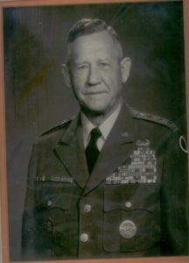 | 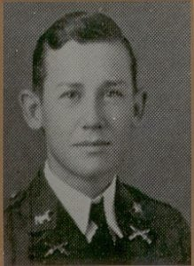
LTG (Ret) James F. Hollingsworth
General Hollingsworth attended North Texas Agricultural College in 1935-36, and is honored for his professional achievements during a long and illustrious military career which saw him steadily advance in grade from Second Lieutenant to the rank of Lieutenant General in the U.S. Army. During the school year 1935-36, he attended the university when it was North Texas Agricultural College, better known as NTAC and participated as a member of the Corps of Cadets. The following year he transferred to Texas A&M. He graduated from Texas A&M in 1940 with a Bachelor of Science degree and was commissioned a Second Lieutenant of Infantry. On July 22, 1940, he joined the 2nd Armored Division at Fort Benning, Georgia and participated in seven campaigns extending from North Africa to the occupation of Berlin in 1945, successively commanding a platoon, company, battalion, and regimental-size armored task force.
Returning from Germany in the fall of 1945, General Hollingsworth commanded the School Troops Regiment, Fort Riley, Kansas and was later the Chief of Combined Arms Instruction at the U.S. Military Academy at West Point and on the General Staff for Department of the Army, as Chief, Senate and House Division, OCLL, Office of the Secretary of the Army. He served in Pakistan for two years as Chief of the Army Element, U.S. Military Assistance Advisory Group. General Hollingsworth then became Deputy Commander, Combat Command A, 1st Armored Division at Fort Hood, Texas and Chief of Staff to the 2nd Armored Division holding that position until assigned to the Office of the Assistant Secretary of Defense (Manpower) in 1961. He became Director, Reserve Affairs Division in 1962 and was later designated Deputy Assistant Secretary of Defense (Reserve and Manpower).
General Hollingsworth Joined the 1st Infantry Division in Vietnam in March 1966. He served as Assistant Division Commander until his return to the United States in May 1967, when he was assigned as Deputy Commanding General, U.S. Army Test and Evaluation Command, Aberdeen Proving Ground, Maryland. In 1968, he first became Deputy Commanding General and later the Commanding General, U.S. Army Training Center, Infantry, Fort Jackson. He became Commanding General, U.S. Army Alaska, in 1970. He left the Alaska Command to become the Deputy Commanding, General, XXIV Corps, Vietnam, in 1971, and later was appointed Commanding General and Senior Advisor, III Military Region, U.S. Military Assistance Command, Vietnam, where he served until 1972.
General Hollingsworth became the Special Assistant to the Army Commander, and later the Deputy Commanding General of Fifth U.S. Army, Fort Sam Houston. In July of 1973, he was assigned to Korea and assumed command of I Corps (ROK/US) Group, the largest field army command in the world, consisting of 13 divisions of ROK and U.S. troops, 185,000 strong. In two and one-half years of command, General Hollingsworth changed the strategy of defense for Korea and developed his short-war concept, which has become the example of the U.S. Army’s forward defense concepts.
In February 1976, General Hollingsworth retired from active duty. He currently is serving as a consultant to the Department of Defense. He is a graduate of the RAF Air/Land Warfare College, Command and General Staff College, and the Army War College. He holds a Masters degree from George Washington University and an Honorary Doctor of Philosophy degree from Chung Ang University in Korea.
He is a recipient of numerous awards and decorations to include the Distinguished Service Cross (2 OLC), Distinguished Flying Cross (2 OLC), Air Medal (“V” Device and 37 OLC), Army Commendation Medal, Purple Heart (5 OLC), and awards from Belgium, Korea and Vietnam.
General Hollingsworth was honored as a Distinguished Alumnus by The University of Texas at Arlington in 1976. General Hollingsworth’s performance while at North Texas Agricultural College in the Corps of Cadets, and his subsequent achievement in the U.S. Army have brought great credit and recognition upon himself, The University of Texas at Arlington and the U.S. Army.

