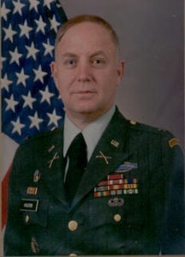 | 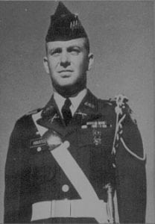
COL (Ret) Jerry B. Houston
Colonel Houston was born in Fort Worth, Texas on August 5, 1941. Upon completion of the Reserve Officers Training Corps curriculum and the educational course of study at The University of Texas at Arlington, he was commissioned a Second Lieutenant and awarded a Bachelor of Arts degree in Psychology in 1963. He also holds a Masters degree in Business Administration from Central Michigan University. His military education includes completion of the Infantry Basic Course, Infantry Advanced Course, the United States Army Command and General Staff College, and the Defense Systems Manager Course. He has held a wide variety of important command and staff positions culminating in his current assignment as Project Manager, Acquisition Information Management and Department of the Army Information Network. Other key assignments held recently include: Department of the Army System Coordinator; Office of the Deputy Chief of Staff for Research, Development, and Acquisition, United States Army, Washington,; Chief, Congressional Coordinator Division, Office of the Assistant Secretary of the Army for Research, Development and Acquisition.
Colonel Houston served in a variety of important career-building assignments preparatory to his most recent duties. His initial tour as a company grade officer was with the 5th Infantry Division at Fort Carson, Colorado where he served as platoon leader, motor officer and company commander with a mechanized infantry battalion. While at Fort Carson, he was given command of an Airmobile battalion headquarters company which was deployed to Vietnam as an element of the 1st Cavalry Division (Airmobile). Upon completion of his tour, he was assigned as the Operations Officer for the Primary Army Helicopter Center and School at Fort Walters, Texas, then returned to Vietnam as a company commander and brigade staff officer of the 101st Airborne Division (Air Assault).
After completing a tour of duty as Assistant Professor of Military Science at The University of Texas at Arlington, he transferred to Fort Hood, Texas where he served as Battalion S-3 (Operations Officer), 1st Battalion 50th Infantry and Division Operations Officer, 2d Armored Division. His last two years at Fort Hood were spent as the Secretary, General Staff, Headquarters, 2d Armored Division. In 1977, Colonel Houston began working in the material acquisition field. He joined the Office of Program Manager, Bradley Fighting Vehicles where he served as Executive Officer and Chief, Management Information Control Office. He was reassigned to Saudi Arabia to command the Technical Assistant Field Team with the mission of training soldiers of the King Abdul Abzes mechanized Infantry Brigade, Saudi Arabian Land Forces, to use United States equipment purchased under foreign military sales.
Awards and decorations which Colonel Houston has received include: the Legion of Merit, the Bronze Star Medal with “V” Device (with two Oak Leaf Clusters), Meritorious Service Medal (with three Oak Leaf Clusters), Air Medals, Army Commendation Medal (with two Oak Leaf Clusters), Combat Infantryman Badge, Parachutist Badge, Ranger Tab, and the Army Staff Identification Badge. Colonel Houston is married to the former Dixie King. They have two children, Robert and Kara.

