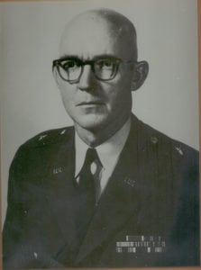 | 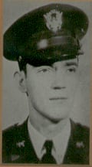
MG (Ret) John S. Hughes
General Hughes is a 1939 graduate of North Texas Agricultural College who is honored for his professional achievements during a long and illustrious military career, which led him from Lieutenant to the rank of Major General in the U.S. Army. During the period 1937-1938, he attended the university when it was North Texas Agricultural College, better known as NTAC, and participated as a member of the Corps of Cadets. In 1938, he served as the Corps Commander. Following completion of the ROTC training and graduation from NTAC, he transferred to the University of Oklahoma to complete his college degree.
He graduated from the University of Oklahoma in 1939 with a Bachelor of Science in Civil Engineering. He was appointed a Second Lieutenant in Field Artillery on 14 July 1940 and entered on active duty on 25 November 1940. General Hughes’ military career took him from instructing gunnery at the Field Artillery School in 1941, to being the Assistant Commandant of the U.S. Army Field Artillery School from 1965-1967. During World War II he commanded a field artillery battalion. Subsequent assignments placed him with the 9th Infantry Division, Supreme Headquarters, Allied Powers, Europe (SHAPE), Office of the Secretary of Defense, Eighth U.S. Army, Faculty of the National War College and the Fifth Infantry Division. He served as the Commanding General of the U.S. Army Communications Zone, Europe and Southern European Task Force. On 27 February 1969, the brilliant career of General Hughes ended in tragedy when he was killed in a military aircraft accident at Linate Airport, Milano, Italy.
He was a graduate of the Armed Forces Staff College, Command and General Staff College and National War College. He was the recipient of numerous awards and decorations, which include the Bronze Star Medal, Legion of Merit and the Distinguished Service Medal.
General Hughes’ performance while at North Texas Agricultural College as the Commander of the Corps of Cadets and his subsequent achievements in the U.S. Army brought great credit and recognition upon himself, The University of Texas at Arlington and the U.S. Army.

