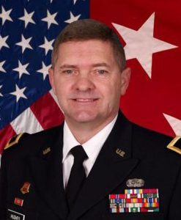 | 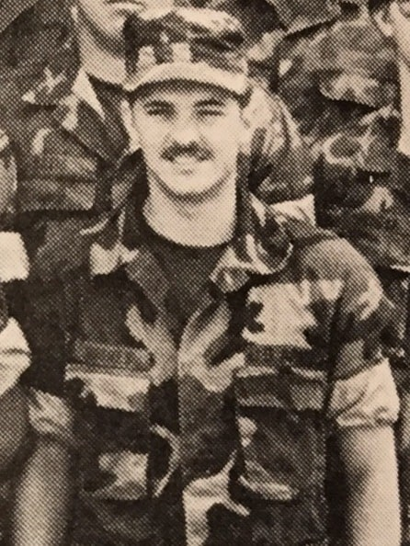
MG (Ret) Daniel P. Hughes
Major General (MG) Daniel P. Hughes, USA (Retired), is a 35-year veteran with combat tours in Operation Desert Shield/Storm (Southwest Asia campaign) and Operation Resolute Support (Afghanistan campaign). Dan was born in South Amboy, New Jersey on April 9, 1960; he attended high school in Massachusetts before his family relocated to Pantego, Texas where he enrolled in the University of Texas at Arlington (UTA). The son of an Army World War II and Korean War veteran awarded the Silver Star, the family service tradition and father’s example drew him to Army ROTC. MG Hughes attended UTA from 1980 to 1983, graduating as a Distinguished Military Graduate with a Bachelor of Arts degree in Political Science (BA) in May of 1983. Beyond excelling as a student and cadet, he participated in a number of activities, to include the Insurgent Team (IT). In his final semester in 1983, Gen Hughes served as Cadet Corps Commander, and was among a select few Army ROTC Cadets from across the nation to be chosen for the George C Marshall award, attending the George C, Marshall Award and Leadership Seminar at the Virginia Military Institute (VMI) in April 1983. He was commissioned an Artillery Officer in the Regular Army.
MG Dan Hughes served in multiple assignments in U.S Army Europe, Federal Republic of Germany and Fort Sill Oklahoma. In 1988-90 he commanded a Firing Battery, 1st Battalion, 17th Field Artillery at Fort Sill, Oklahoma. He later served as the Fire Direction Officer of the 75th Field Artillery, XVIII Airborne Corps and VII Corps during Desert Shield/Storm.
MG Hughes’ career was on the cutting edge of modernization and development of computerized fire support systems. He was also directly responsible for the Blue Force Tracking System and fielded that system to ground units in Tuzla, Bosnia. This same system was used to great tactical advantage in both Iraq and Afghanistan as well as in other areas of the world. He served from 2003-2006 in the Office of the Secretary of Defense as the Director for Missile Defense. In 2006-2011 he served as the Program Manager for the Joint Tactical Radio System-Ground Domain with the primary responsibility for the development of modernized radio systems for all of DOD.
From 2011-2016 the United States Defense Department was undergoing reorganization with formation of new agencies to manage transformation well into the 21st century. MG Hughes, was selected to lead many high-level positions such as Commanding General of the Natick Soldier System Center and Deputy CG of the Army Research Development and Engineering Command. He also served as Program Executive Officer for Command Control and Communications-Tactical. As the Deputy Commanding General of the Combined Security Transition Command-Afghanistan he was responsible for manning, equipping and funding of the Afghan National Security Forces. In 2016-2018 he completed his active service career as the Director for Test for the Missile Defense Agency at Redstone Arsenal, Alabama.
After a thirty-five-year career MG Hughes awards include the Army Distinguished Service Medal, Defense Superior Service Award with Oak Leaf Cluster, Legion of Merit with three Oak Leaf Clusters, Bronze Star Medal, Meritorious Service medal with three Oak Leaf Clusters, Afghanistan Campaign Medal, Southwest Asia Service Medal, Office of the Secretary of Defense Staff Identification Badge, Air Force Space Badge. His Military Training and Education includes, Field Artillery Officer Basic and Advance Courses, U.S Army Command and General Staff Course, the U.S Army Program Managers and Executive Managers Courses, Defense Systems Management College, Defense Security Assistance Course and the Industrial College of the Armed Forces.

MG Hughes was selected as UTA Distinguished Alumni in 2016. Following retirement, he continued service to the nation in the defense industry. He was recently selected for the position as Vice President for Missile Defense and Command, Control, Communications, and Intelligence for Cypress International, in Alexandria, Virginia. Major General Hughes and his wife Kathy currently reside in Potomac Falls, VA. They have two grown children Daniel and Kimberly.

