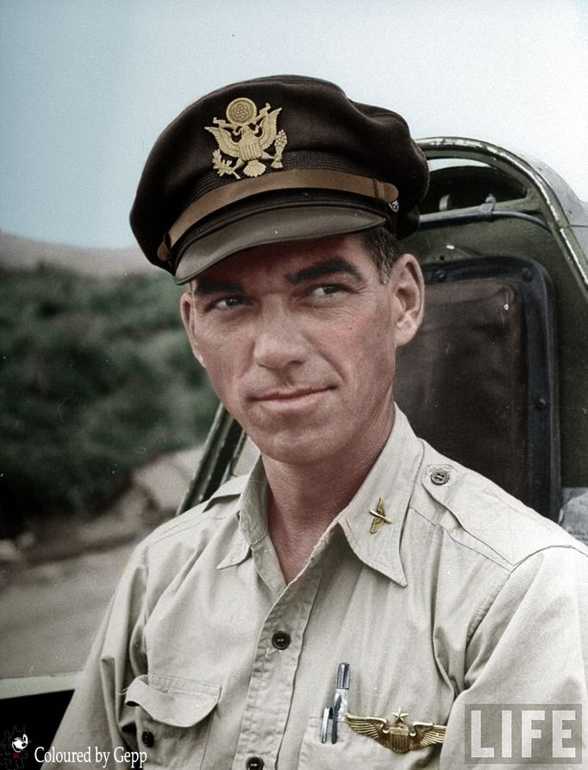 | 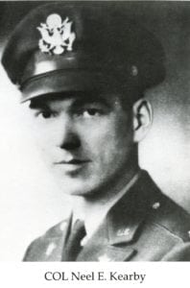
COL Neel E. Kearby
(KIA)
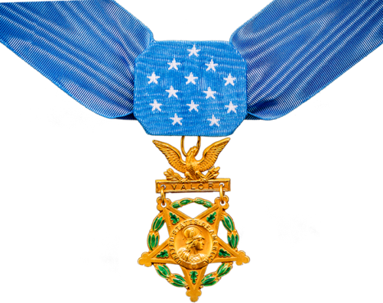
Colonel Neel E. Kearby attended North Texas Agricultural College in 1930-31 and is honored for his professionalism achievements during an illustrious military career which saw him rapidly advance in grade from Second Lieutenant to the rank of Colonel in five years. He earned the Medal of Honor for his courageous actions during World War II.
During the school year 1930-1931, he attended the University when it was North Texas Agricultural College and participated as a member of the Corps of Cadets. He earned his degree in business administration from The University of Texas at Austin in 1937. He immediately enlisted as a flying cadet at March Field, California. He trained at Randolph and Kelly Fields, Texas, where he earned his rating and commission in February 1938. He was assigned successively to the 94th and 40th Pursuit Squadron at Selfridge Air Force Base, Michigan, in a series of positions including flight commander.
He was next sent to the Canal Zone in December 1941 as the commander of the 14th Pursuit Squadron where he served until August 1942. He then returned to the United States as commander of the 348th Fighter Group at Bradley Field, Connecticut, and Westover Field, Massachusetts. He took the group to the Pacific in May 1943, flying the P-47 “Thunderbolt.” He was promoted to Colonel on September 23, 1943, and the next month, on October 11, 1943, he earned The Medal of Honor.
In this action, he volunteered to lead a flight of four fighters to reconnoiter a strongly defended Japanese air base. The Medal of Honor citation in part, reads: “Having observed enemy installations and reinforcements at four airfields, and securing important tactical information, Colonel Kearby saw an enemy fighter below him, made a diving attack and shot it down in flames. The small formation then sighted 12 enemy bombers and 36 escorting fighters. Although his mission had been completed…his fuel was running low, and the numerical odds were 12 to 1…he gave the signal to attack. Diving into the midst of the enemy airplanes he shot down three in quick succession. Observing one of his comrades with two enemy fighters in pursuit he destroyed both enemy aircraft. The enemy broke off in large numbers to make a multiple attack on his airplane but despite his peril he made one more pass before seeking cloud protection. Coming into the clear, he called his flight together and led them to a friendly base. Colonel Kearby brought down six enemy aircraft in this action, undertaken with superb daring after his mission was complete.”
Colonel Kearby’s eventual score was 22 enemy aircraft destroyed in the air. (Only 11 other airmen had more kills in both World Wars.) On March 5, 1944, he was killed while flying on a fighter sweep mission near Wewah, New Guinea. After downing one enemy fighter, he was attacked by three others and, with a burst of fire; they sent his P-47 into a headlong dive into the dense jungle below.
His awards include The Medal of Honor, this nation’s highest award for valor, two Silver Stars, four Distinguished Flying Crosses, and five Air Medals. On May 4, 1979, the Officer’s Club and Visiting Officer’s Quarters at Kelly Air Force Base, San Antonio, Texas, were dedicated to his memory.
Colonel Kearby’s performance while at North Texas Agricultural College in the Corps of Cadets and his subsequent achievements in the U. S. Army Air Corps brought great credit and recognition upon himself, The University of Texas at Arlington, and the U. S. Army Air Corps.

