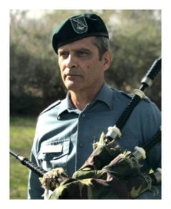 | 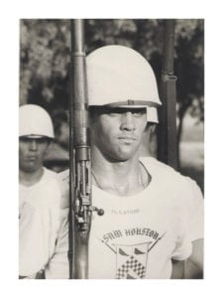
LTC (Ret) Mark B. Latham
LTC Mark Latham came to the University of Texas at Arlington in 1972. As a cadet, he was an active member of the Sam Houston Rifles for two years, completed the Airborne Course in 1974, and was the Corps Commander and Junior Training Company Commander his senior year. He graduated in 1976 as a Distinguished Military Graduate with a bachelor’s degree in Political Science and was commissioned in the Infantry.
Following the Infantry Officer’s Basic Course, the Mechanized Infantry Officer’s Course, and Ranger School, he was assigned to the 3rd Infantry Division in Germany, where he served as a Platoon Leader, Scout Platoon Leader, and Company Executive Officer. He attended the Armor Officer’s Advanced Course and, following graduation from the Special Forces Qualification Course, transitioned into Special Forces and served for five years in the 5th Special Forces Group. There he commanded Special Forces Operational Detachments and a Special Forces Company. He later served as Operations Officer for the 1st Special Warfare Training Battalion and as Chief of Individual Training in the U.S. Army John F. Kennedy Special Warfare Center and School.
LTC Latham was among the early Joint Specialty Officers resulting from the Goldwater-Nichols DOD Reorganization Act of 1986, and he served in critical staff positions at Major Army, Unified, and Allied Command levels where Special Forces and Joint qualification were essential and critical. These assignments included the Army Materiel Command, Army Special Operations Command, Military Group El Salvador, United States Special Operations Command—Washington Office, Special Operations Command Europe, and Supreme Headquarters Allied Powers Europe. These assignments focused on planning for the future of US and Allied Special Operations Forces as an essential component command in force projection. Additionally, LTC Latham advised the El Salvador Armed Forces Doctrine and Educational Command in its formative years.
Some of his awards and decorations include the Defense Meritorious Service Medal with one Oak Leaf Cluster, Joint Service Commendation Medal, Meritorious Service Medal with two Oak Leaf Clusters, Armed Forces Expeditionary Medal, Army Commendation Medal, Expert Infantry Badge, Parachutist Badge, Ranger Tab, and Special Forces Tab. LTC Latham retired from active duty in May 2004.
Following retirement, he served two years as a Title 10 Instructor for joint, combined, and multinational operations at the Command and General Staff College, at Fort Leavenworth and at Fort Lee. He then returned to Arlington where he served as a substitute school teacher and, at one time, as a funeral director’s assistant. He currently helps with forestry management at the family farm in East Texas and serves on the Cadet Corps Alumni Council executive board as Historian.
In retirement, he developed a keen interest in the Great Highland Bagpipe, taught himself to play, and has served as piper for the Maverick Task Force during the Medal of Honor Parade in Gainesville, Texas, as well as at other occasions throughout the local area. He heartily supports the maverick, independent-minded, spirit among our cadets. LTC Latham lives in Arlington with his wife Seba. They have two adult sons who both work as educators.

