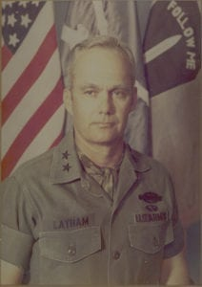 | 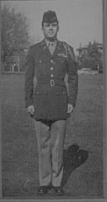
MG (Ret) Willard Latham
General Latham is a 1949 graduate of the North Texas Agricultural College who is honored for his professional achievements during a long and illustrious military career which saw him steadily advanced in grade from Second Lieutenant to the rank of Major General in the U. S. Army.
During the school year 1945 and later in school year 1948-1949, he attended the University when it was North Texas Agricultural College, better known as NTAC, and participated as a member of the Corps of Cadets. He served as the Corps Sergeant Major in 1945 and was Commander of the crack drill team, the Sam Houston Rifles, in 1948. During the school year 1948-1949, he served as the Cadet Corps Commander being selected for this highest position because of his outstanding leadership abilities and military bearing. Following completion of his ROTC training and graduation from North Texas Agricultural College, he entered the U. S. army in January 1949 as an Infantry Second Lieutenant. He later received a Bachelor of Arts degree from Texas Christian University.
General Latham’s military career took him from leading an infantry platoon in combat during the Korean War to being the Deputy Commander of combat ready Army Corps in Germany. General Latham’s career began by leading a mortar and rifle platoon in Korea for two years. He served as a Company Commander with the 82nd Airborne Division, 31st Infantry Division and the 2nd Armored Division. In April 1957, General Latham, then a Captain, returned to the University, then known as Arlington State College, and served on the staff as an Assistant Professor of Military Science until 1960. He later went on to command the 2nd Battalion, 6th Infantry of the Berlin Brigade. In Vietnam, he served as a Battalion Commander in both the 1st Infantry Division and the 9th Infantry Division. Following Vietnam he commanded the 197th Infantry Brigade at Fort Benning, Georgia, and as an Assistant Division Commander of the 3rd Infantry Division in Germany. Upon his return to the United States from Germany, he assumed the prestigious position, Commandant of the U. S. Army Infantry School, Fort Benning, Georgia, a dream of all infantrymen. He went on to an it of important joint command in the NATO Defense Command and his final assignment was as Deputy Commander VII Corps. General Latham officially retired from active duty on November 1, 1980. He presently serves as Coordinator for the Dallas Council on World Affairs.
He is a graduate of the Armed Forces Staff College, Command and General Staff College, and the Army War College.
He is the recipient of numerous awards and decorations to include the Distinguished Service Medal, Silver Star (2 awards), Legion of Merit (3 awards), Distinguished Flying Cross (3 awards), Bronze Star Medal (3 awards), Meritorious Service Medal, Air Medal (14 awards), Army Commendation medal (2 awards), and Purple Heart (2 awards). He also proudly wears the Combat Infantryman Badge with Star to signify his role in combat as an infantryman during two conflicts. He also wears the wings of an Army parachutist and the coveted Ranger tab.
General Latham was honored as a Distinguished Alumnus by The University of Texas at Arlington in 1973.
General Latham’s performance while at North Texas Agricultural College as Commander of the Corps of Cadets, and his subsequent achievements in the U. S. Army have brought great credit and recognition upon himself, The University of Arlington and the U. S. Army.

