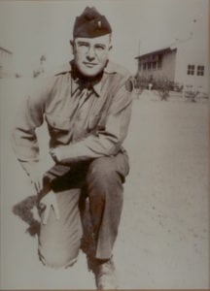 | 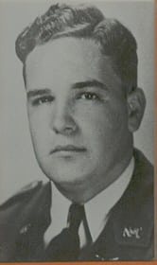
LT Almer Jasper Mann
(KIA)
Almer J. “A.J.” Mann was born in Laredo, Texas in 1919. He graduated from the Laredo High School in 1937. He attended the North Texas Agricultural College from 1937-1939 as a Pre-Law major. He was Vice-President of the Aggie Bar Club, was in the Honor Society, a football letterman on the 1937 team, and a sports reporter. He was Cadet Technical Sergeant, a “Ramp Supervisor”, and Vice-President of the Non-Com Club. He became a Captain on the Cadet Corps Staff, a member of the ROTC Cadet Officers Club, the Kampus Klub Kadets social club, and Phi Kappa Theta (Scholarship) Club. A. J. Mann was selected for “Who’s Who and Why” in the 1939 Junior Aggie (Yearbook). During the 1938-1939 term he was chairman of the Student Faculty Committee. He was a high achiever; all recognized his fine personality and leadership qualities. In the Fall of 1939 he entered The University of Texas at Austin to study law. He continued to demonstrate scholarship and leadership excellence.
At the beginning of World War II, he was among the first to volunteer for active duty. He entered the Army in January 1942. Following graduation from Officer Candidate School, he was assigned to Company C, 407th Infantry Regiment, 102nd Infantry Division. His Company Commander at that time remembers “How pleased I was that a man like A. J. would be there to help lead them into battle. Integrity, compassion, and resolve emanated from A. J.”
LT Mann was serving as Executive Officer of his Company when it was committed in its first attack against the 10th German Panzer Division in the bloody fighting along the Roer River. The Company Commander advanced the Company beyond the assigned limited objective. It was pinned down before a strong German fortified defense and suffered heavy casualties. During the night of 29 November and until relieved on 30 November, two-thirds of the officers and nearly three-fourths of the men were killed or wounded. The Company Commander was killed and LT A. J. Mann assumed command. On 1 December LT Mann regrouped, resupplied, and revitalized the shocked survivors. He immediately planned a new attack. On 2 December LT Mann led his Company in the assault of Rurdorf. Following the successful attack and subsequent defense of the objective, he was killed.
LT Mann earned the Bronze Star Medal, the Purple Heart, and Combat Infantryman Badge. Reports say he received another Bronze Star Medal and was recommended for the Silver Star Medal. Since records cannot be found, due to death and fire, three General Officers, all combat veterans of the Roer fighting, reviewed LT Mann’s heroic deeds. All stated that he deserved the Silver Star Medal; one General Officer said a Legion of Merit Medal was deserved, and this General Officer along with another said LT Mann should have been considered at the time for a Distinguished Service Cross.

