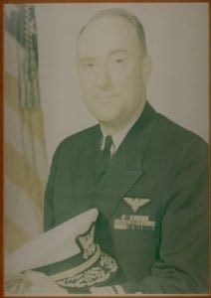 | 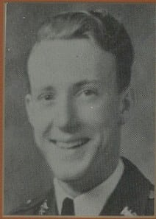
RADM (Ret) John D. McCubbin
Admiral McCubbin attended North Texas Agricultural College (NTAC) from 1932-1934 and is honored for his long and distinguished military career in the U. S. Coast Guard.
Admiral McCubbin is from Dallas where he attended Sunset High School and was a member of the Junior Reserves Officers Training Corps for four years. During his years at North Texas Agricultural College, he served as Cadet Captain and Company Commander within the Corps of Cadets. Upon graduation from North Texas Agricultural College, he took the nationwide examination for the Coast Guard Academy and was accepted in August 1935. In May 1939, he graduated with a Bachelor of Science degree in Marine Engineering and was commissioned an Ensign and assigned to the USCG Cutter Taney, home ported in Honolulu, Hawaii, but operating in the Central and West Pacific.
In December 1941, Admiral McCubbin was accepted for flight training at the Pensacola Naval Air Station. Upon completion of his pilot training he had various assignments as an anti-submarine warfare pilot. He was then assigned to the search and rescue agency under the Joints Chief of Staff. While there he assisted in the development of the U. S. position for both the Provisional and Permanent International Civil Aviation organization and traveled as a technical advisor to the U. S. Delegate to Regional Air Navigation meetings.
Subsequent assignments have included: pilot, search and rescue (SAR) and administration in support of CCGD 13 and CCGD 17; Commanding Officer/Pilot of SAR and Administration in support of CCGD 17 in Juneau, Alaska; Executive Officer for SAR and Administration CCGD 14 in Honolulu, Hawaii; Assistant Chief of Aviation Division/VIP Pilot, Coast Guard Headquarters; Operations Officer (Western Area-Pacific) for Commander, Western Area, San Francisco, California; Operations Officer and Chief of Staff for Commander, 17 Coast Guard District in Juneau, Alaska. It was while in this last assignment that Admiral McCubbin was selected for flag rank and promoted to Rear Admiral. He was then assigned as Chief, Office of Reserve on the staff of the Commandant, Washington, D.C.
In May 1971, Admiral McCubbin was assigned as Commander, 8th Coast Guard District, New Orleans, Louisiana, which included most of Texas, Louisiana, Mississippi, and Alabama in addition to the Florida Panhandle and New Mexico. He was responsible for the marine safety on the confluence of the intercostals waterway, the inland waterways of the Mississippi Basin and the waters of much off the Gulf of Mexico.
On June 30 1973, Admiral McCubbin retired after more than 45 years in uniform, 34 of which was commissioned service. His awards and decorations include the Legion of Merit, Air Medal, American Defense Service Medal with clasp, American Theater Medal, European/African Theater Medal, World War II Victory Medal, National Defense Service Medal, USCG Expert Rifle Medal, USCG Expert Pistol Medal, and the Command Sea Badge.
Admiral McCubbin’s dedicated and exemplary service to his country bring great credit to himself, The University of Texas at Arlington and the U. S. Coast Guard.

