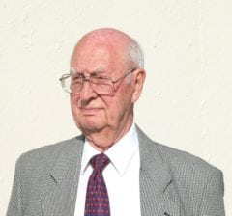 | 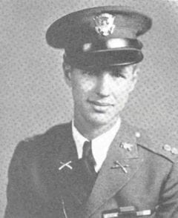
COL (Ret) George C. McDowell
Colonel McDowell entered North Texas Agricultural College in 1930 and graduated in 1932. He elected to attend a third year and was designated Company Commander of D Company. In 1933 he won a competitive appointment to the United States Military Academy at West Point and graduated in 1937 as a Second Lieutenant in the Field Artillery.
McDowell’s initial assignment was to Fort Sill in the 18th Field Artillery, a horse-drawn artillery unit. With the mechanization of the army in 1939 he was transferred to the Ordnance Department for duty with the Air Corps. After attending the Aviation Ordnance School at Aberdeen Proving Grounds, Maryland and Langley Field, Virginia, he remained as an instructor and participated in the development of bomb handling equipment and specialized vehicles that were used in World War II. With the rapid expansion of the Army and the Air Corps in 1941, he was assigned positions as Ordnance Officer at Bowman Field, Kentucky, and Ireland Task Force, New Orleans Air Base. After two months at Birmingham Air Base, Alabama, as Ordnance Officer, Third Support Command, his unit was ordered to Washington, D.C., re-designated as the 12th Air Support Command of the Western Task Force for the November 1942 invasion of French Morocco under command of General Patton. As Ordnance Officer of the Air Support Command he was involved in logistical planning, including the landing and movement of units and equipment.
McDowell spent two years overseas in North Africa and Italy responsible for the logistics for arms and equipment necessary for both the Royal Air Force and the U.S. Tactical Air Support for the Fifth and Eighth army Operations. In 1944 McDowell was assigned to the War Department general staff. He assumed responsibility for standardizing and approving procurement of newly developed small arms, ammunition, and specialized vehicles for the Army and Air Corps units.
He received an MBA from Harvard Business School in 1948 and transferred to the Air Force. He spent the next seven years in the Pentagon and at Wright Patterson AFB. McDowell signed the procurement order and saw installed the first four UNIVAC computers for the Air Force, the Navy, the Bureau of Census, and Wright Patterson AFB. After a year at the Industrial College of the Armed Forces, he was assigned from 1958 to 1960 to the Air Force ballistic missile program, first in California and later as project officer and commander of the Thor Missile Force in England. Royal Air Force crews were trained to eventually man this force of 60 missiles with atomic warheads. It proved successful in countering the Russian missile threat.
After subsequent assignment to the Pentagon in the Office of Secretary of Defense’s Weapons System Evaluation Group, he left the Air Force and entered the real estate business in Houston. Among his awards and decorations are the Legion of Merit with Oak Leaf Cluster, the Army Commendation Medal, and the Air Force Commendation Medal.
He formed his own real estate firm in 1961, and his firm (Clark McDowell & Kic, Inc.) has grown to become the foremost residential property management firm in Houston. Colonel McDowell served as an Adjunct Professor at the University of Houston Continuing Education School for nine years, teaching property management. He served as the first president of the Houston Chapter of the Military Officers Association of North America and as president of his West Point class.
Colonel McDowell is married to the former Rae Woods. They have two children (Larry and Linda), two grandchildren, and three great-grandchildren.

