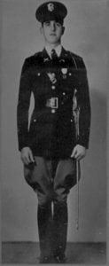 | 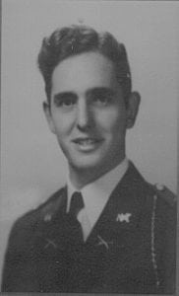
LT Constance Mims
(KIA)

Lieutenant Mims was a 1940 graduate of North Texas Agricultural College who is honored for his courageous service to his country resulting in the sacrifice of his life while serving in the United States Army during World War II to preserve the freedom of the United States and the world.
During the period 1939 to 1940, he attended the University when it was North Texas Agricultural College, better known as NTAC, and participated as a member of the Corps of Cadets. For his outstanding leadership qualities and military bearing, he was selected to serve as the Corps Commander in 1940. Following the completion of ROTC training and graduation from North Texas Agricultural College, he transferred to the University of Texas at Austin to complete his degree.
After graduating from college, he entered the United States Army. He was subsequently commissioned a 2nd Lieutenant in the Infantry after attending Officer Candidate School at Fort Benning, Georgia. As World War II progressed, LT Mims was deployed to Germany with the 35th Infantry Division. On November 2, 1944 in the vicinity of Aulnois, France, LT Mims led a patrol of five men into enemy territory at dusk with the mission of probing enemy defensive positions. He skillfully directed the movement of his patrol through a mine field and several barbed wire entanglements then deployed the troops near the objective. He moved forward alone to reconnoiter, encountered a German soldier and rendered him prisoner. The first German soldier regained consciousness and was killed by LT Mims in the ensuing fight. The noise of the struggle had alerted enemy positions in the area and LT Mims led his patrol back to the American lines through a concentration of machine-gun fire. By his aggressive leadership and initiative, LT Mims secured information which contributed to the success of an attacked launched in the area several days later. In recognition of his courageous actions and outstanding leadership, LT Mims was awarded the Silver Star Medal.
On December 17, 1944, LT Mims died of wounds sustained in close combat while still serving with the 137th Regiment of the 35th Infantry Division. Two days later, the 35th Infantry Division was withdrawn from the battle line after having been in the thick of the fighting on the European continent for 162 consecutive days.
In addition to the Silver Star Medal, LT Mims was the recipient of the Bronze Star Medal, the Purple Heart, and Combat Infantryman’s Badge.
LT Mims performance while at North Texas Agricultural College as the Commander of the Corps of Cadets and the sacrifice of his life in the defense of the United States while serving in the United States Army brought great credit and recognition upon himself, the Corps of Cadets and the University of Texas at Arlington.

