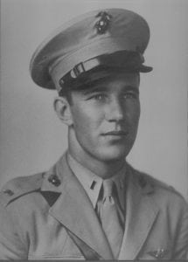 | 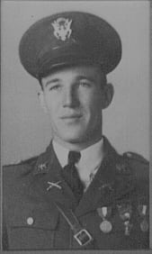
CPT John Luther Morgan, Jr.
(KIA)
Captain John Luther Morgan, Jr., began his distinguished military career as Battalion Commander, First Battalion, at North Texas Agricultural College in 1940. He came to North Texas Agricultural College in 1938 as an Eagle Scout and an honor graduate of Arlington High School. A pre-med student, he was on the Dean’s List and was active in numerous campus organizations.
He was born in Fort Worth, Texas on October 29, 1921. He was the son of a dirt-poor family and he suffered just about every possible disadvantage that a growing boy could have thrust upon him. He accepted these disadvantages while never ceasing in his pursuit of excellence. Luther worked at campus jobs as well as evening jobs in town to help support his family.
Luther Morgan enlisted in the U. S. Navel Reserve as a Seaman, Second Class on his twentieth birthday, October 29, 1941, then was called to active duty on December 4, 1941 to undergo elimination flight training. Upon completion of this training, Morgan was designated an aviation cadet. He graduated from Fixed Wing Flight Training on September 17, and accepted a commission into the United States Marine Corps Reserve.
Morgan reported to 4th Marine Aircraft Base Defense Wing and set sail for Pearl Harbor, arriving there on December 8, 1942 where he joined Marine Fighting Squadron 213, flying F4U Corsairs. First Lieutenant Morgan became an “ace” in his first three weeks in combat in the Solomons. During one mission, he was able to shoot down a bomber and a fighter despite overwhelming odds. On a subsequent mission involving intense aerial combat, LT Morgan completely destroyed three zeros within a period of 90 seconds. LT Morgan was transferred stateside on December 9, 1943. He was promoted to Captain on February 1, 1944 and transferred to the regular Marine Corps on September 7, 1944. On September 18, 1944, his unit was again called to action in the Pacific. His tour was served aboard carries – the USS Essex, the USS Bougainville, and the USS Bunker Hill – still flying Corsairs. When his squadron returned to the states in early 1945, Captain Morgan remained in the Pacific. He served aboard the escort carrier, Bougainville, training new Navy and Marine Corps pilots on carrier flying in preparation for the Iwo Jima and Okinawa operations. On March 25, 1945, Captain Morgan was detached to VMF 452 aboard the USS Bunker Hill. T hree days later, on March 28, he was killed when his plane was hit by enemy ground fire during a strike against a heavily fortified enemy airfield near Okinawa.
Captain Morgan was considered “one of the best of the younger pilots in Marine Corps Aviation.” His medals include the Distinguished Flying Cross, Air Medal, Purple Heart (posthumously awarded), Asiatic-Pacific Area Campaign Medal, American Theatre Campaign Medal, and the World War II Victory Medal. He was also recommended for the Navy Cross. In the fall of 1955, the members of the Sam Houston Rifles planted a tree as a living memorial to a fallen comrade. This tree today stands on the northeast corner of College Hall.
It is an honor to all of the men already inducted into the Hall of Honor to be joined by Luther Morgan. His accomplishments and contributions to this world are legion.

