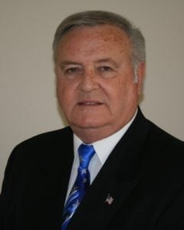 | 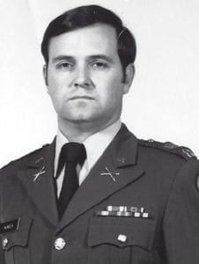
LTC (Ret) Ronald L. Munden
LTC (Ret) Ronald L. Munden graduated from Duncanville High School in 1966 and then attended The University of Texas at Austin for one year before entering the U.S. Military Academy in 1967. He graduated in 1971 and was commissioned in the Field Artillery. He had a number of artillery assignments, including three battery commands, prior to being assigned to the UTA Military Science Department in the Spring of 1981.
His exceptional service as Assistant Professor of Military Science at UTA is the reason he has been selected as an Honorary Member of the Hall of Honor. While at UTA he was instrumental in establishing a number of programs and initiatives that became an integral part of the Military Science Department. At that time, Captain Munden researched, designed, produced, and procured a set of historic flags used by the University and Military Science Department and also obtained historical uniforms that were used by the color guard. He did extensive research on the history of the department and worked with others to obtain a number of pictures that were hung throughout the department. This helped the cadets to recognize and understand the long relationship of the Military and UTA.
One of LTC Munden’s most lasting accomplishments was the acquisition of six 75mm Pack Howitzers that formed a group named the Carlisle Cannons and that carried on the history of the University’s cannons of the past—Little Bertha and Roaring Rebel. Three of those six cannons are still in use within the department and are integrated into other activities throughout the university. He acquired a silver punch bowl and encouraged alumni and friends of the department to purchase cups that could be used for ceremonial events, a tradition still in place today. He negotiated and began a Military Science extension center at Southern Methodist University. He was very active in public affairs and spoke on a number of local radio stations about the Army and ROTC at UTA. He and the cadets published a Military Science Department yearbook when UTA stopped publishing its own. He finished his tour of duty at Arlington as the Corps of Cadets Commandant.
LTC Munden went on to have an illustrious career in the Field Artillery. He attended the Command and Staff College after leaving UTA, then served as the Operations Officer for the 3/18th Field Artillery Battalion, Executive Officer of the Operations and Intelligence Section (G2/G3) for III Corps Artillery. He then served as the Operations Officer and Executive Officer for the 212th Artillery Brigade. He deployed to Korea as the Inspector General of the 2nd Infantry Division and then returned to Fort Sill where he served as the Operations Officer (G3) for III Corps Artillery, writing plans for and deploying five Brigades to Operations Desert Shield/Desert Storm. He next commanded the 1/30th Artillery Battalion. LTC Munden completed his Army career as the Chief of Staff/Deputy Commander of III Corps Artillery and retired in July 1992.
After retiring from the military, LTC Munden worked for three corporations. Initially his career focused on Human Systems Integration. Two of the systems he evaluated were the MIA2 Main Battle Tank and the M109A6 Paladin 155mm Howitzer. He developed and managed a division of Camber Corporation supporting the areas of military operations and training, counter-terrorism training, and testing and evaluation in the U.S. and overseas. As part of this effort he managed the digitization of the 4th Infantry Division (in the U.S. and Iraq). He retired in 2011 as Senior Vice President for International Operations and Business Development for Camber Corporation.
Currently, LTC Munden spends time assisting veterans and their spouses with VA, MEDICARE/MEDICAD, and disability support. He lives in Belton, TX with his wife of 45 years, Lou Anne. They have two married daughters and three grandchildren.

