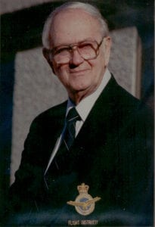 | 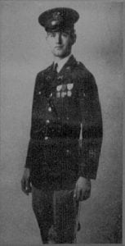
Nicky Naumovich
Mr. Naumovich’s interest in aviation began at an early age when Charles Lindbergh was his hero. Little did he realize than that fascination with flying would lead to his having to stay in the United States training R.A.F. pilots during World War II. He was one of the youngest instructors assigned to the Army Reserve as a civilian instructor because of the shortage of men with his flight rating.
Mr. Naumovich attended North Texas Agricultural College in 1938-1941 to study Aeronautical Engineering and played a significant role in the Corps of Cadets. In 1938-1939 he was honored as the Best Drilled Cadet in the Regiment, a tribute never before bestowed on a freshman, and was the only non-commissioned officer selected to be in the Sam Houston Rifles. While in the Corps, he rose to the rank of Lieutenant Colonel, became a Regimental Executive Officer, and commanded the Sam Houston Rifles.
In 1941, Mr. Naumovich became a flight instructor and primary aviation and ground instructor for the Royal Air force at the Basic Flight Training Station in Terrell, Texas. He later volunteered for the U.S. Army and was placed on reserve status to continue as flight instructor under the lend-lease program. He trained both United States and British pilots. He requested active duty in 1944 after 4000 hours in advanced flight instructing and was assigned to Keisler Field. After his release from active duty in 1946, he continued in aviation. He established a flight training school under the veterans program in Dallas and trained over 400 veterans in four years. The school later evolved into a successful crop dusting operation covering Dallas area farms and the Mississippi Delta.
By 1950, his interests had turned to land development and construction. Besides achieving noted business success, he contributed significantly to the growth of the Dallas area. Mr. Naumovich’s fund raising expertise enabled him to develop land and build the University of Plano (no longer in operation). In 1969, he became one of the pioneer developers in Plano and in 1973, more houses were built in his subdivisions than were built in the entire city of Dallas. He worked closely with the Plano Planning commission, the Park Board, the Plano School District, and the Chamber of Commerce and was elected Head of the Developers’ Committee. Mr. Naumovich’s diligence, and that of others, caused Plano to become the fastest growing area of North Texas in the 1970’s. During his career as a general contractor, Mr. Naumovich generated millions of dollars in employment for workers on VA homes in the Casa View area, custom homes in North Lake Highlands, apartment complexes in Dallas, and on development of the subdivisions of University Estates and Parker Road estates in Plano.
In 1977, Mr. Naumovich and his son founded Parsec, Inc., an energy research company that manufactures building materials. Parsec has become a giant in its field, with markets throughout the United States, Canada, Southeast Asia, and the Middle East. The company is currently working on a contract, with an agent in England, which will give access to the European Common Market. Mr. Naumovich has been active in trade organizations and has served on committees in Washington to promote energy conservation in construction. Mr. Naumovich currently serves as Chairman of the Board of Parsec, Inc.
In the early 1980’s, a group of World War II British pilots, who had returned to the North Texas area to live, banded together and formed the British Flight Training School Association. In 1985, Mr. Naumovich started a search for the American instructors to add to the membership and take part in the reunions held in alternating years in England and in Texas. He was a key player in Terrell’s Andrew Carnegie Library establishing a British Museum. Currently, he is Membership Chairman of a group planning the building of a flight museum at Terrell’s airport.
Mr. Naumovich and his wife, Betty Allison, currently reside in Dallas. They have one son and two grandchildren.

