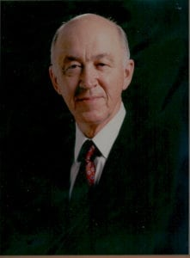 | 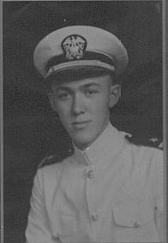
Dr. Wendell H. Nedderman
Wendell H. Nedderman, Ph.D., is honored for nineteen years of dedication and support to the Corps of Cadets during his tenure as President of The University of Texas at Arlington.
Dr. Nedderman is a native of Iowa and was born in 1921. He graduated from Lovilia High School and earned a B.S. in Civil engineering from Iowa State University in 1943. From there he immediately joined the Navy and was sent to the U.S. Naval Academy’s Reserve Midshipman’s School. During World War II, Dr. Nedderman served as Engineering Officer aboard the Destroyers USS Patterson and USS Charles S. Sperry. By 1946, he had earned the Asiatic-Pacific Ribbon with six stars and the Philippine Liberation Ribbon with two stars.
After his discharge from the Navy, Dr. Nedderman took a position as Instructor of Civil Engineering at Texas A&M and obtained his Master’s Degree in 1949. He obtained his Ph.D. in Civil Engineering from Iowa State University in 1951 while on leave from A&M. His twelve year tenure at A&M culminated as Graduate Advisor of the Department of Civil Engineering and as Professor.
Based on his accomplishments, he was selected as the first Dean of Engineering at The University of Texas at Arlington. This faith was more than justified when he phased in five engineering B.S. programs by 1965; five M.S. programs phased in from 1966 to 1969 and UTA received authorization to commence the Ph.D. in Engineering in 1969. During the two year period 1967 to 1969, Dr. Nedderman actually held three positions simultaneously as a Vice President; Graduate School Administrator; and Dean of the School of Engineering. Recognition of his talents resulted in his appointment as Acting University President in November 1972 and official confirmation as University President in February 1974.
During Dr. Nedderman’s tenure as University President, 21 Baccalaureate, 27 Masters, and 17 Doctoral degree programs were added. The value of the University Plant (land, buildings, improvements, equipment, and library books) increased from $51,637,610 to $279,969,268. Enrollment increased by over 10,000 students during his Presidency.
In 1976, Dr. Nedderman was inducted into the Scabbard and Blade Military Honor Society. He has always been a staunch supporter of the Carlisle Cannons Salute Battery and the Sam Houston Rifles. The Hall of Honor concept was fully supported by Dr. Nedderman and came to fruition during the 1980 Spring Semester. His steadfast belief in Corps traditions led to his participation in the development and execution of the Corps Advisory Council on January 21, 1981.
During both Desert Shield and Desert Storm Operations, Dr. Nedderman supported his students’ commitment to their country. His guidance cut through red tape so administrative procedures dealt with each student on a case-by-case basis to ensure courses were completed with credit and next semester prepayments were refunded rapidly.
Dr. Nedderman resides with his wife, the former Betty Vezey in Arlington, Texas. They have four sons and seven grandchildren.

