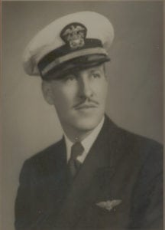 | 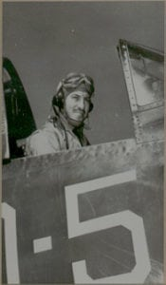

Dr. Cothburn M. O’Neal
Dr. Cothburn M. O’Neal is a former student of the University of Texas at Arlington who is honored for his professional achievements during a long and illustrious career as an educator.
Dr. O’Neal attended North Texas Agricultural College from 1923 to 1925. He received a BA Degree from Trinity University in 1927 and MA and Ph.D. degrees from the University of Texas at Austin in 1934 and 1940 respectively. In 1938, after teaching and directing band in high schools at Weslaco, Gladewater, Dallas, and Peacock Military Academy in San Antonio, he returned to North Texas Agricultural College as a Professor of English.
In 1931, Dr. O’Neal joined the Texas National Guard, where he served until 1941. During this period of time, he earned a commercial pilot’s license. He joined the United States Navy as a Lieutenant JG in 1941, following the bombing of Peal Harbor, and completed Naval Flight training at Corpus Christi, Texas. During World War II, Dr. O’Neal served in the Pacific Theater as an aviator aboard the aircraft carrier Hornet. He flew the F6F Hellcat, torpedo bombers, and the F4U Corsair. During the war, he attained the rank of Lieutenant Commander. After his release from active duty, at the end of the war, he continued to serve in the Naval reserve and retired from Active Reserve in the early 1950’s.
Dr. O’Neal returned to North Texas Agricultural College in 1945. He twice served as Acting Chair of the English Department and headed the Fine Arts Department from 1956 to 1960. He was a member of the Graduate Faculty and Graduate Advisor. Dr. O’Neal later served two years as Assistant to the President during the preparation of the University’s self-study, a requirement for accreditation by the Southern association of Colleges and Universities.
Dr. O’Neal retired in 1972. He is the author of eight novels and a number of scholarly articles and for several years was a book critic for The Dallas Time Herald. In 1953, he was elected to the Texas Institute of Letters and, in 1966, received the Piper Distinguished Professor Award as one of the ten outstanding professors in the state. He has been a member of the Authors Guild of America, the National Speakers Bureau, The Advertising Federation of America and Director of the Tarrant County Arts Council. Dr. O’Neal is listed in Contemporary American Authors, Who’s Who in the Southwest, the Dictionary of International Biography, and the Directory of American Scholars. The University of Texas at Arlington honored him as a Distinguished Alumnus in 1971 and again in 1995. He was honored by the Boston University Library, which has established a Cothburn O’Neal Collection. As an accomplished musician, Dr. O’Neal played clarinet in the San Antonio Symphony Orchestra for three seasons and has played saxophone and clarinet in a number of dance bands. He was Choir Director for the First Presbyterian Church in Arlington for three years and an Elder of the Church, serving as a Commissioner to the General Assembly in 1950. Dr. O’Neal is the inventor of, and holds patents for the Accu Vote Voting Machine.
From 1972 until her death in 1992, Dr. O’Neal was married to Bess Cox of Dallas. Dr. O’Neal and his present wife, the former Lucille Curry of Dallas, reside in Fort Worth. He is presently a member of the Fort Worth City Band and the Past President’s Council of the UTA Alumni Association.
Dr. O’Neal’s performance while at North Texas Agricultural College, in the Corps of Cadets, as well as his subsequent achievements in service to his country and dedication to this university, has brought great credit and recognition upon himself, the University of Texas at Arlington, and to the United States Navy.

