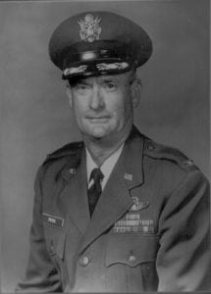 | 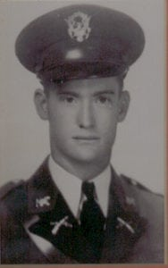
COL (Ret) Thornton C. Peck
Colonel Peck, a former student of the University of Texas at Arlington, is honored for his professionalism achievements during a long and illustrious career in the United States Air Force, and for his service to his community. He was commissioned a Second Lieutenant in the United States Army Air Corps and steadily advanced to the rank of Colonel.
Colonel Peck attended the University from 1938 to 1940 when it was North Texas Agricultural College. He studied Agricultural Engineering and was a member of the Cadet Corps throughout this period, serving as a Platoon Commander in D Company. Colonel Peck was also a member of the Cadet Officers Club and the Future Farmers of America. In late 1940 he entered the Flying Cadet Training Program of the U. S. Army.
Colonel Peck’s early assignments included Flight Instructor at Barksdale Army Air Field, LA; Flight Instructor, Operations Officer, Squadron Commander, and Air Inspector at Columbus Army Air Field, MS; Adjutant, 85th Fighter Wing, Florida Blanca Army Air Base, and Commander of the Air Rescue Squadron, 13th Air Force at Clark AFB in the Philippine Islands. In 1949 Colonel Peck completed the Air Command and Staff School at the Air University, Maxwell AFB, AL. From 1950 to 1956 he was Director of Material, Bergstrom AFB, TX and in 1952 was attached to the Navy and served with Test Aircraft Unit 132.4.2 on Kwajalein Atoll in the Marshall Islands, piloting F84 aircraft that flew through the atomic clouds at Eniwetok. He was promoted to Colonel in 1954 and in 1957 attended the Air War College, Regular Course, also at Maxwell AFB.
His later assignments included Base Commander and Support Group Commander, RAF Station, Wethersfield, England and from 1960 to 1962 he was Chief of the Logistical Plans Division at the Pentagon. From 1963 to 1965 he was Deputy Director for Material for the Tactical Air Warfare Centre at Eglin AFB, FL and was Director of Material for the 7th Air Force at Tan Son Nhut Air Field, South Vietnam, in 1965 and 1966.
Prior to his retirement in 1970 Colonel Peck was Commander of Eglin AFB, FL. During this period of time he received numerous letters of appreciation not only from local congressmen but other community leaders in the Fort Walton Beach area for his support on civic actions programs.
Immediately after retirement he operated a motel during which period of time he sponsored 18 refugees from South Vietnam; four of whom are now medical doctors. He later helped charter the First National Bank of Destine, FL and served as Director for 15 years. He presently serves as a Director for the First National Bank of Panama City, FL and the First Northwest Florida Bank of Fort Walton Beach. In 1992 he became a Paul Harris Fellow of International.
Colonel Peck is rated as a Command Pilot and his decorations include the Legion of Merit, the Bronze Star Medal, and the Army and Air Force Commendation Medals. Other awards include the American Defense Service, American Campaign, and his WWII Victory Medals; the National Defense Service, Vietnam Service and Vietnam Campaign Medals, as well as Air force Longevity and Air Force Outstanding Unit Awards.
He and his wife, the former Evelyn Lee, also a student at North Texas Agricultural College, presently reside in fort Walton Beach, FL. They are the parents of one married daughter, Linda, and have one grandson.
Colonel Peck’s performance while at North Texas Agricultural College in the Corps of Cadets and his subsequent achievements in service to his country and his local community have brought great credit and recognition upon himself, the University of Texas at Arlington, and to the United States Air Force.

