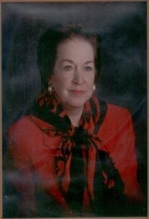 | 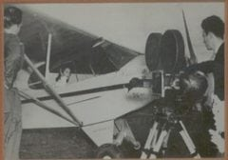
Roze McCoy Porter
Roze McCoy Porter attended North Texas Agricultural College (NTAC) from 1939 to 1940 and is honored for a lifetime of distinguished service in diverse careers of aviation, fashion, journalism and as an author and a military wife.
In 1939, with World War II begun in Europe, President Roosevelt instituted through the Civil Aeronautics Authority a program to train 10,000 fliers. Roze became one of only two women accepted in the CAA Pilot Training course offered at North Texas Agricultural College. On completion she entered an elite group of only 2,000 women in the United States awarded a pilot’s license by 1940. She joined the “Ninety-Niners,” an organization for women pilots, and flew with the Civil Air Patrol.
Through her aviation skills she contributed significantly to the war effort. She completed American Airlines Instrument Flying School training, and became a Link Training Instructor. The “Link” was the latest in flight simulator training at the time. During 1942 to 1943, she and three other women instructors train over 1,300 Navy and Marine pilots. She headed the Link Trainer Department, Consolidated Aircraft Corporation from 1943 to 1945 and was an Instrument Simulator Operator for B-24 test pilots. The combined endeavors of Roze and other women instructors released pilots for combat and other vital duties, as well as, providing hundreds of pilots the skill to fly in adverse weather.
Roze married Jim Porter, an Army Air Corps Pilot, on December 26, 1943. As an Air Force wife and mother while in the United States and abroad, she was deeply involved in community relations. She was presented to the Crown Princess of Japan for her work with a Japanese Children’s hospital. In Montgomery, Alabama she was recognized for her participation with the March of Dimes and the annual All Girls State.
She gained prominence in the fashion field both in the United States and Japan. She owned a successful fashion school and modeling agency; coached the Maid of Cotton contestants in Montgomery, Alabama; was fashion coordinator during the Olympic Games in Tokyo’s historical Imperial Hotel; and was fashion coordinator for one of Las Vegas’ largest department stores.
Her free-lance writing appeared regularly in Tokyo’s Asahi Evening News, Las Vegas Review Journal, and other magazines internationally. In 1975, Roze began five years of extensive research on her book, “Thistle Hill, The Cattle Baron’s Legacy.” The book has been well received and is in its second edition.
Roze resides with her husband Jim, Lieutenant Colonel, USAF (Retired), on Eagle Mountain Lake, Azle, Texas. They have three children and six grandchildren.

