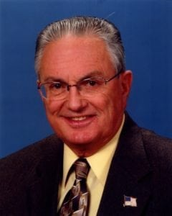 | 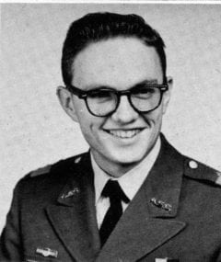
COL (Ret) Clifton (C.A.) Potter
Clifton (C.A.) Potter was a graduate of Polytechnic High School, Fort Worth, Texas, and entered Arlington State College in 1959. He very much enjoyed ROTC, although not anticipating that he would make the U.S. Army a career. He was a member of the Sam Houston Rifles, and was a distinguished military graduate in 1963. He entered the Army as a Second Lieutenant of Artillery. University of Texas at Arlington, as the college became, and honed skills required for future success.
His first assignment was at Fort Bliss, Texas, (Air Defense) and he was then deployed to Vietnam. Based on extensive outdoor/hunting experience, he was assigned to advise both regional forces and ARVN infantry units. Following completion of the Artillery Advanced Course and a stint at the training center, he returned to Vietnam and served with the 4th Infantry Division Artillery as a battalion S-3 (6-29 FA) and Division Artillery Asst. S-3. He also taught artillery at the U.S. Armor School (Fort Knox, Kentucky). Following graduate school, Colonel Potter was deployed to Germany as S-3 of a Lance Missile Battalion and as S-3 of an FA Brigade, which was force artillery for the 2nd Armored Cavalry Regiment. He was sent to U.S. Forces Command as the Executive Officer to the CG, and subsequently commanded the 1st, Bn (First Lance) 12th FA for three years. Later assignments included Senior Advisor I Corps Artillery (Utah Army National Guard), Chief Current Operations (and Chief, Terrorism Counteraction) for U.S. Army Europe, Commander 210 FA Brigade (Force Artillery for the 2nd Armored Cavalry Regiment) and Commander Readiness Group Denver. He retired from the U.S. Army in 1990.
Colonel Potter’s awards include the Combat Infantry Badge, the Legion of Merit, the Distinguished Flying Cross, the Bronze Star Medal with “V” device and three oak leaf clusters, the Meritorious Service Medal with four oak leaf clusters, the Air Medal, the Army Commendation Medal with two oak leaf clusters, the Purple Heart, Vietnam Cross of Gallantry, Parachute Badge, and others. He also was awarded the Ancient Order of Saint Barbara for service with and to the Field Artillery and the Order of Saint George for Service with and to the branch of Armor and Cavalry.
Colonel Potter’s education includes: BA, Arlington State College; MPA (Master’s degree of Public Admin), University of Missouri; U.S. Army Command and General Staff College and the U.S. Army War College.
After retiring from the Army, Colonel Potter, based on extensive nuclear weapons security assignments and terrorism counteraction experience, took an entry- level position in casino security in Colorado to start a new career in security. One year later he had been promoted to General Manager of that casino and, instead of security, chose casino management. He subsequently was Compliance Director of a large casino and Assistant General Manager/Acting General Manager of that casino. He retired completely in 2003 so as to devote more time to skiing and fishing.
Colonel Potter and his wife LaVerne reside in Golden, Colorado. They have two children (Daniel and Kathryn) and four grandchildren (Zachary, Emily, Makena and Jack), all of whom also live in Colorado.

