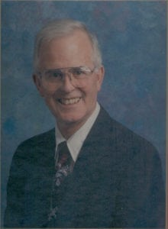 | 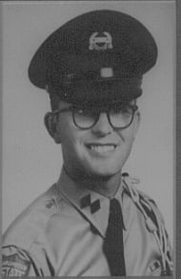
Zack Prince
Zack Prince, who enrolled at Arlington State College (now University of Texas at Arlington) in 1957 as a cadet student, currently serves as the University’s Registrar and will complete 35 years of association with the institution this spring.
Born March 13, 1939, he lived with his parents, Zack and Helen Prince, in Fort Worth, Texas. Graduating from Polytechnic High School in 1957, he enrolled at Arlington State College becoming active in the Corps of Cadets and other student activities. Mr. Prince marched for four years with the Sam Houston Rifles, serving a term as team Executive Officer. He obtained the rank of cadet Lieutenant Colonel while serving as the Cadet Corps Executive Officer. In May, 1961, he graduated in the institution’s first four-year class with a Bachelor’s of Business Administration degree. As a Distinguished Military Graduate, he received a regular United States Army commission.
Entering active duty in May 1962, Mr. Prince attended the United States Army Adjutant General Officer training course at Fort Benjamin Harrison, Indiana. He was then stationed at Fort Bliss, Texas and assigned to the Headquarters Unit, U.S. Army Air Defense Command, where he served as an officer in the Adjutant General’s section. He was later promoted to Captain in the United States Army Reserves.
Returning to civilian life, Mr. Prince obtained a position as Assistant Registrar at Arlington State College in June 1964. Later he was promoted to Associate director of Admissions and then to Registrar and Director of Admissions in September 1970. He obtained a Master of Arts Degree in History from University of Texas at Arlington in 1971. Throughout the years he has attempted to improve the services of the Admissions and Registrar’s Office at University of Texas at Arlington.
His professional activities include the chairmanship of several committees for the Texas Association of Collegiate Registrars and Admissions officers, and a term as Chair of the North Texas Articulation Council. Under his leadership that council developed and implemented in 1985, the first statewide electronic transcript network between colleges. He was co-chair and then chair of a task force that implemented the Texas Common Course Numbering System to aid students in transferring institutions. This plan was recognized as an outstanding articulation project by the American Association of Collegiate Registrars and Admissions Officers. Mr. Prince recently received a special Presidential Award from the Texas Registrars’ Association for 30 years of constructive effort with the organization.
Active in church and community activities, he has served for many years as a Deacon and Bible teacher at Tate Springs Baptist Church. He was President of Arlington Kiwanis Club and was a member of the Tax Equalization Board for the City of Arlington, 1975-1980. He was a member of a special advisory committee to the Superintendent and Board of the Arlington Independent School District, 1980-1983. He is a long term member of the Corps of Cadets Advisory committee and currently serves as a volunteer for HCA Arlington Medical Center.
He and his wife, Donna, live in Arlington, and they have four adult children; Zack Scott, Holly, Kasha, and Elise.

