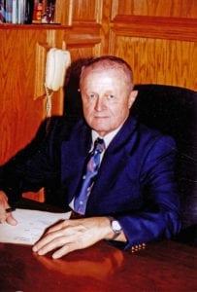 | 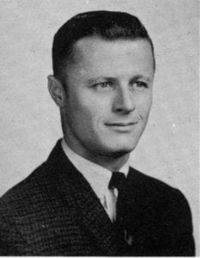
Ronald M. Rendleman
Ronald M. Rendleman grew up in University Park, Texas, and his love and understanding of all things mechanical has proved to be an asset throughout his life. Model airplanes, motorcycles, hot rods, and ski boats filled his youthful ambitions. He graduated from Highland Park High School in 1958. His 1933 Plymouth that he purchased in 1957 for $75 followed him to Arlington State College (ASC). The car was at the airport when he returned from Vietnam, and he still owns the car today. Ron participated in the first march of 160 miles from Arlington to Fort Hood, Texas. Rendleman was in the first four-year graduating class of ASC. Another first for Ron was obtaining his pilot’s license from the original college flight-training program sponsored by the U.S. Army. He was commissioned as a 2nd Lt. in the U.S. Army in 1963. His assigned combat branch was Armor, where he served in Fort Knox, Kentucky, from October 1963 to January 1964.
Fort Wolters was where Ron completed primary helicopter school in September of 1964, and he then attended advanced school at Fort Rucker, Alabama, until February 1965. His next assignment was to fly gunships from Fort Riley, Kansas, to Camp Irwin, California, but after only two weeks he received his orders for Vietnam.
He left San Diego in April 1965 on the helicopter carrier Iwo Jima, and arrived at Vung Tau three weeks later where he ferried Huey helicopteres off the carrier. At Camp Holloway, Pleiku, in Vietnam, Ron joined the 119th Assault Helicopter Company gunship platoon. During his tour, he flew more than 250 combat missions and over 500 combat hours, earning 20 air medals during a one-year tour from April 1965 to April 1966. Later he went through instrument training at Fort Rucker, and then became an instructor back at Fort Wolters. Ron left the Army as a Captain in 1967 and moved back to Dallas.
While later General Tommy Franks was rigging flight helmets with two earpieces and two microphones to receive and transmit communications to both artillery bases and other helicopters in Vietnam, Ron was also at work. He used his skills and experience as a pilot, welder, and engineer to outfit the Huey with extra armor plate in strategic places to protect the crew, and came up with a way to add firepower to the gunship. The Army adapted these innovations in various forms on future aircraft.
Always innovative, Ron negotiated a deal with some of the Air Force fly boys. For a few cases of beer, he traded for a piece of their hardware, and he was able to adapt the first napalm bomb to be dropped from a Huey (a mission only recently declassified, and not necessarily approved by the flight commander).
He has been a Scoutmaster in the Boy Scouts, and has been involved with his church for many years. He is an avid hunter, and he holds several patents for his work in the printing industry. His success in auto racing and show cars is legendary.
Ron is married to Martha, his college sweetheart, and they have two children, Ryan and Rhonda.

