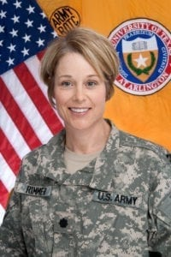 | 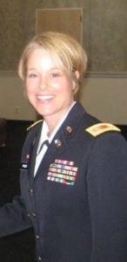
LTC (Ret) Lora A. Rimmer
LTC Lora A. Rimmer heard about college ROTC through a friend at the University of Kansas. As she learned about the military, the more involved she became in the cadet battalion, and the more certain she felt that she had found a home. She realized how very much she enjoyed leading and teaching cadets and soldiers. Upon graduation she was commissioned in the Signal Corps and received her first choice of assignment to Germany.
After a tour in Germany and deployments to Saudi Arabia and Iraq, she left active duty but continued to serve in the Army Reserve. Six years later she returned to active duty as the Operations Officer for a Signal Brigade. Later she commanded a Signal Company. LTC Rimmer found her next assignment as the S1 for the 2nd Brigade, 75th Training Division to be very challenging. The brigade composition included Active Duty, Reserve, and National Guard units, with both military and civilian personnel, physically dispersed across four states. This experience may have contributed more to her future selection as a Professor of Military Science than any other duty assignment in her career.
Upon completing Command and General Staff College, LTC Rimmer became the 1st Cavalry Division’s Network Operations Officer for its preparation and deployment to Iraq. In that role, she synchronized and integrated Wide Area Network and network configuration management to create the Army’s first digital Relief-in-Place, resulting in a seamless transition between outgoing and incoming divisions. LTC Rimmer became the Senior Military Analyst and Leadership Development and Training Branch Chief supporting the Combined Arms Center, which is widely regarded as the intellectual center of the Army. Across the command she was recognized as being the subject matter expert for Leadership Development and Training and for having superb communications abilities.
In May 2011, LTC Rimmer became the Professor of Military Science at the University of Texas at Arlington (UTA). Her previous education and experience set the stage for her exceptional performance in this role. Although she assumed command of a very active and productive program, she took it to new heights. She developed an exceptional track record as a trainer, educator, coach, mentor, and role model, leading to her recognition as the Military Science Professor of the Year in 2014, from a pool of 275 highly qualified candidates from the United States Army. She cultivated positive relationships with the university faculty and staff and with the local community to increase awareness of Army ROTC and its benefits. She encouraged her cadets to take an active part in university and local community activities. She also helped to establish a more active role for the Military Science Department within the university.
LTC Rimmer developed a close relationship between the Cadet Corps Alumni Council, the cadets, and the department staff, and effectively used the alumni organization to support her efforts to the point the alumni felt as though they were members of her organization. This provided the impetus for the alumni to become even more active and to provide an even higher level of support.
LTC Rimmer retired in 2015 and started her second career in Baldwin, Kansas, with health and fitness as a focus. She owns and teaches at her small business named Yoga Love. She has been a registered yoga teacher since 2015 and has over 300 hours of experience. Outside of her career, she is a full-time mom and head cheerleader for her son Ian. She serves as a lead coach for Girls on the Run at Baldwin Elementary Intermediate Center, and she is the program council advisor and mentor for the Zeta Tau Alpha sorority at Baker University. She remains an ardent supporter of the Military Science Department at UTA through her Life Membership in the Cadet Corps Alumni Council, visits to the university, and by continuing a mentorship role with former cadets. Her positive impact on the young men and women whose lives she touched continues to enhance the legacy of excellence and achievement few have reached in their careers.

