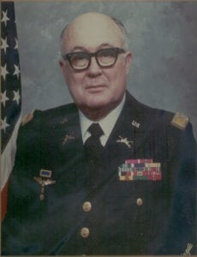 | 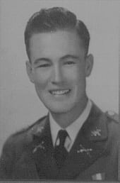
COL (Ret) Cecil E. Roberts
Colonel Cecil Edward Roberts was born in Burkburnett, Texas on May 26, 1919. He attended public school in Lamesa, Texas graduating from high school in 1936. In February 1938, he enrolled at North Texas Agricultural College in Arlington, Texas. His major was geology. He was in the Corps of Cadets. In his last year, 1939 to 1940, he was appointed Battalion Commander of the first battalion of the Corps with the rank of Cadet Major.
In December 1940, Colonel Roberts was appointed a United States Army Reserve second Lieutenant of Infantry. He entered active duty with the First Armored Division at Fort Knox, Kentucky on March 20, 1941.
During World War II, he served in tank units as platoon leader, company commander, battalion maintenance officer, operations officer, and executive officer. In 1945, he was promoted to the grade of Major. In 1946, he was appointed First Lieutenant in the Regular Army of the United States in the Infantry. When the Armor Branch was formed in the Army, he was transferred to that branch. Roberts commanded the Fourth Tank Battalion in the first Armored Division and later served as the Executive Officer of Combat Command A, First Armored Division, Fort Hood, Texas, 1952-1954.
Colonel Roberts served as Assistant U. S. Army Attaché in Greece, 1949-1952. He served as U. S. Army Attaché in Bolivia 1957-1959 and Guatemala 1962-1965. He served as General Staff Officer in the Office of the Chief of Research and Development, U. S. General Staff 1959-1962. He was the Commanding Officer of the 108th Military Intelligence Group with Headquarters in New York City when he retired from the Army in 1966.
During his service, Colonel Roberts received the following awards and decorations: U. S. Army Legion of Merit, two Bronze Stars, Army Commendation Medal, Purple Heart, Presidential Unit Citation, American Defense Medal, American Theatre Medal, European-African-Middle East Theatre Medal with three battle stars, World War II Victory Medal, Occupation Medal, National Defense Medal with one oak leaf cluster, Belgium-Croix de Guerre; Greek Order of Phoenix, degree of Brigadier; Bolivian Order of Condor, degree of Officer; Guatemalan Cross of Military Merit, II Class, and Gold wings of an Honorary Military Pilot from the Bolivian Air Force.
Colonel Roberts has a Bachelor of Arts degree in government from Texas Technological University, Lubbock, Texas and a Master of Arts degree in Latin American Studies from American University, Washington, D.C. He graduated from the Armored School, Fort Knox, Kentucky; The Command and General Staff College, Fort Leavenworth, Kansas; The Strategic Intelligence School, Washington, D.C. and the Army Language School, Monterrey, California. He is author of a book “A Soldier from Texas.” In 1968, he was the Technical advisor for the David Wolper film, “The Bridge at Remagen,” because his unit captured the bridge during World War II. In 1980, he worked with The Services Kinema Corporation of Buckinghamshire, England in making a documentary film about the capture of the bridge at Remagen, Germany. This film was produced for Sandhurst Military Academy in England.
Colonel Roberts is a life member of the National Rifle Association, the Retired Officers Association and the Military Order of World Wars.

